Extra Information:
Monday:
- Spellings given out to learn for Friday;
- Homework given out to be completed by Friday;
- Bring home reading book to school.

Tuesday and Wednesday:
- PE kit.

Friday:
- Spelling test.
- Homework handed in.
- PE kit taken home.
- Class Achievement Assembly.

This term, Year 6 are learning about
Courage, Hope and Forgiveness
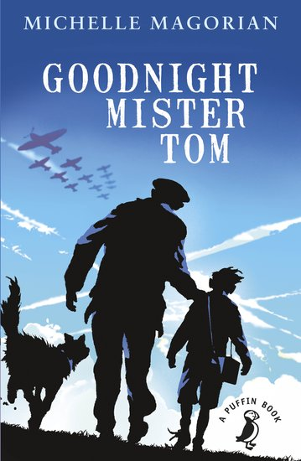
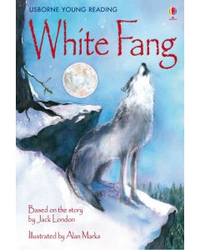
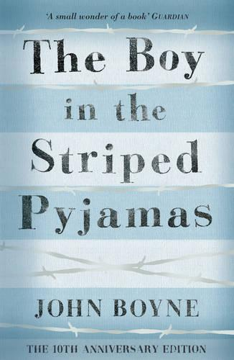

This term we are studying as follows:

English:
- Key texts: The Boy in the Striped Pyjamas, Goodnight Mister Tom, The Diary of Anne Frank; White Fang, One Dog and his Boy.
- Narrative; Diary writing; Journalistic Writing; Discussion and Persuasion; Explanations.
Mathematics:
- Measurement, Algebra, Statistics, Geometry
- Arithmetic

Science:
- Electricity
- Light
Religious Education:
- Christianity: The Gospels
- Christianity: Salvation and Easter
History:
- The Holocaust
- 20th Century Popular Culture
Art and Design:
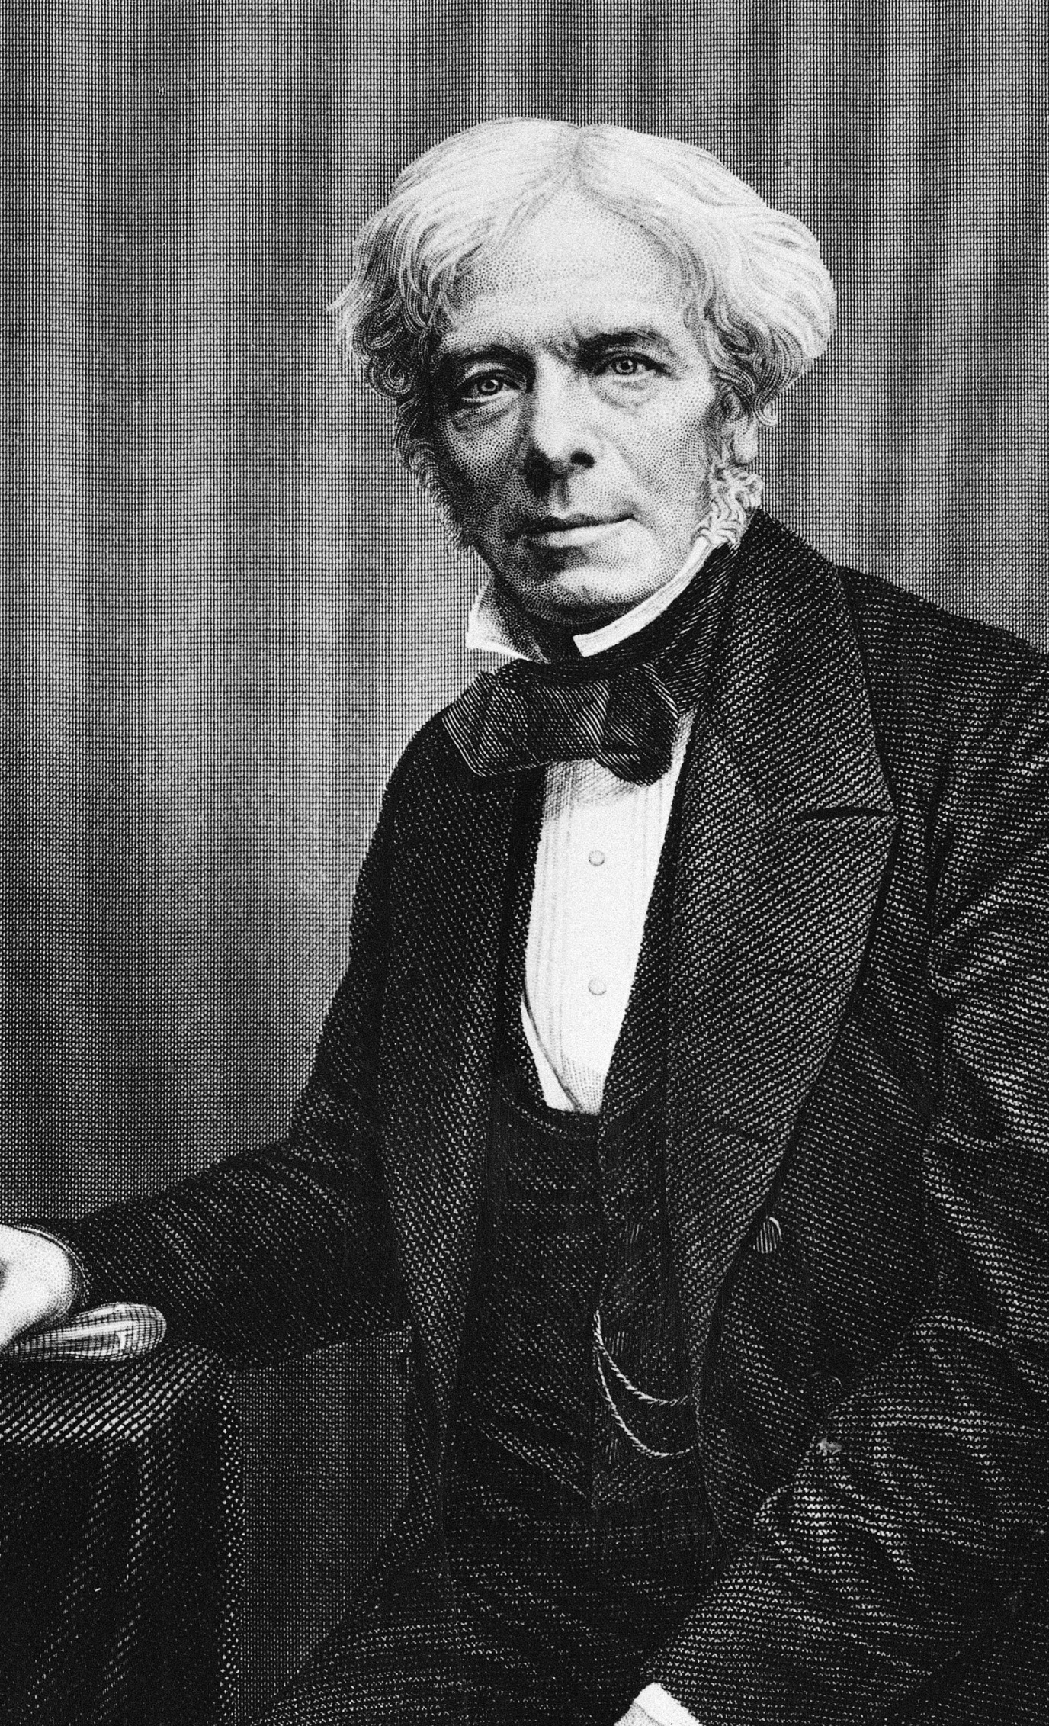
- Political Art
- Responses to the Holocaust
Music:
- Jazz, Latin, Blues; Hip Hop
Computing:
- Internet: bias and validity
- Coding
Spanish:
- En el café
Physical Education:
- Football, Rugby, Badminton, Gymnastics



