Christ Church C of E Primary School

Shieldfield Green
Shieldfield
Newcastle upon Tyne
NE2 1XA

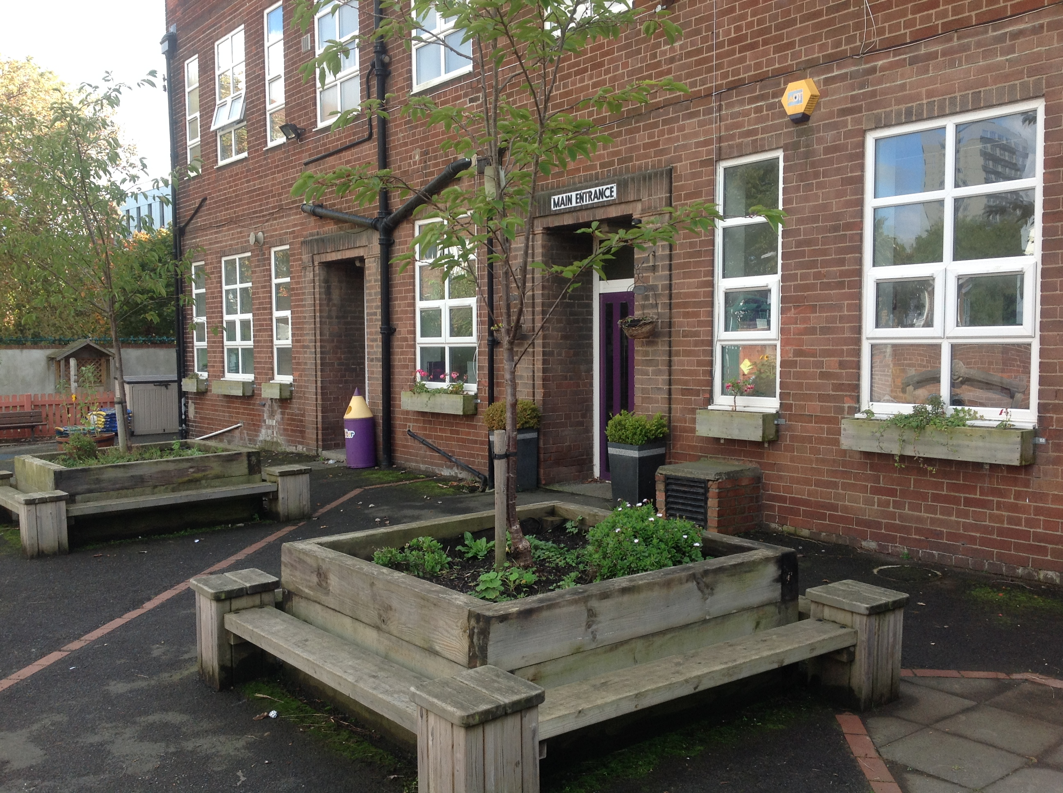
Telephone (0191) 2328054
Fax (0191) 2331828

Website:www.christchurch.newcastle.sch.uk

Head Teacher – Sandra Furno
Chair of Governors – Dr Linsley de la Hunt

City of Newcastle upon Tyne
Civic Centre
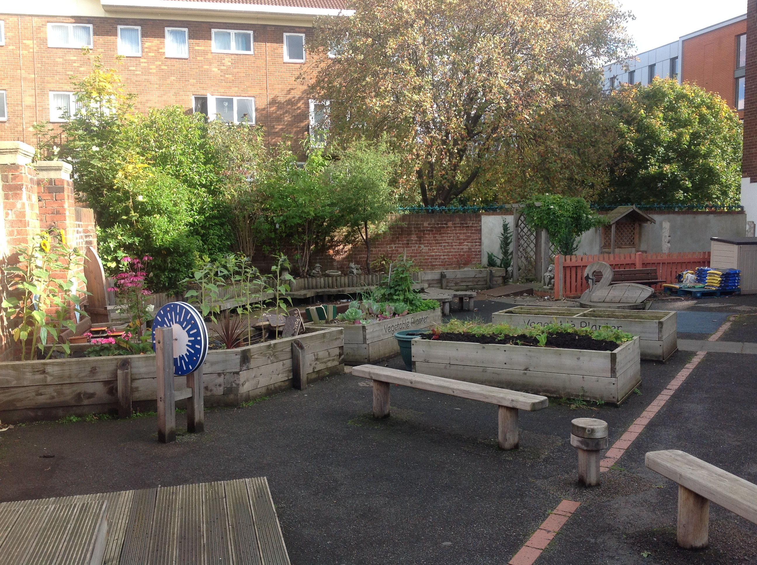
NE1 8PU
0191 2328520

Mission Statement
Reach for the stars
Values
- As a church school our foundations for living and learning are the life and teaching of Jesus Christ. The message of God’s love for all and the Christian values of respect, friendship, love, forgiveness, trust and spirituality are at the heart of all school life.
- We are an inclusive school which means we welcome everyone into our school. We thrive on diversity.
- We strive to ensure that children are happy here, that they enjoy their education and are given every opportunity to reach their full potential.
- We endeavour to provide a caring, safe and engaging environment where individuals feel valued and that they belong.

Learning
- At Christ Church we put the wellbeing, development and progress of our children first. We help children to become confident and successful learners by discovering their gifts and talents. We appreciate hard work, encourage perseverance and resilience and celebrate achievement.
- Our mission is to develop independent learners with active and creative minds, a sense of understanding and compassion for others, and the courage to act on their beliefs.
- We seek to engender the joy and wonder of learning by providing a creative and challenging curriculum which makes learning vivid, real, enjoyable and fun.

Partnership
- We work as a team, listening to children, considering their views and their parents and involving them in decisions that affect them. We encourage partnerships with governors, parents and our local parish community and promote partnerships locally, nationally and globally in order to become active citizens and responsible stewards of our world.


Our aims
- To strive constantly to raise the standards of education by ensuring pupil access to the highest quality of teaching and learning.

- To raise pupils awareness and levels of understanding of the basic beliefs of Christianity.

- To create a caring, stimulating and enjoyable environment for pupils and staff.

- To develop a caring and considerate attitude towards others and to promote habits of self-discipline and acceptable behaviour.

- To help pupils appreciate human achievement and aspirations.

- To encourage pupils to understand the world in which they live, and the interdependence of individuals, groups and nations by instilling respect and understanding for other races and moral values.


- To promote and develop an understanding of the relationship between people and their environment, developing the ability to ask and answer questions about other places demonstrating an awareness of localities beyond their own.

- To develop an interest in other times and other places and to stimulate an understanding of local, national and international events and issues.

If a child lives with criticism
They learn to condemn

If a child lives with hostility,
They learn to fight.

If a child lives with ridicule,
They learn to be shy.

If a child lives with shame,
They learn to be guilty.

If a child lives with tolerance,
They learn to be patient.

If a child lives with encouragement,
They learn confidence.

If a child lives with praise,
They learn to appreciate.

If a child lives with fairness,
They live with justice.

If a child lives with security,
They learn to have faith.

If a child lives with approval,
They learn to like themselves.

If a child lives with acceptance and friendship,
They learn to find love in the world.

STAFFING

Mrs S Furno Head Teacher
English Coordinator
Pupil Progress and Assessment Coordinator
Child Protection & Safeguarding
Collective Worship Coordinator
Music Coordinator

Mr Brown Deputy Head
Health & Safety Manager
Mathematics Coordinator
PE Coordinator

Mrs H Allison Early Years Teacher
Early Years manager
SENCO

Miss Jones YR5/6 teacher

Mr Colledge YR4/5 teacher

Mrs M Jones-Wright Teacher – YR3
Science Coordinator

Mrs T Mann Teacher - Year 2
History & Geography Coordinator

Mrs R McKay Early Years Teacher
Art & Design Coordinator
Design Technology Coordinator

Mrs M Power Teacher – YR2
RE Coordinator
EAL Coordinator

Mrs Ong YR1 Teacher

Miss E Ryan EAL Teacher
Computing Coordinator

Miss D Durkin Nursery Teacher (presently on maternity leave)
PSHCE Coordinator
Pupil Council

Mrs J Vardy Nursery Nurse/First Aider

Mr A Harland Higher Level Teaching Assistant

Mrs R Arnott Teaching Assistant
Miss Cliff Teaching Assistant
Ms E George Teaching Assistant
Mrs J Jenkinson Teaching Assistant
Mr J Pousson Teaching Assistant
Miss K Robertson Teaching Assistant
Mrs S Robinson Teaching Assistant
Mrs H Tait Teaching Assistant

Mrs J Ward Administrative Officer/First Aider
Mrs Garbutt Personal Assistant to Leadership Team & Governors

Mr J Wright Caretaker & Breakfast Club / lunch time assistant
Mrs I Graham School Cleaner
Miss A Tweddle School Cleaner & Breakfast club assistant

Mrs M Wrightson Cook
Mrs D Turner Kitchen Assistant
Ms Slasor Kitchen Assistant

Mrs S Khodabandeh Lunch-time Assistant
Breakfast Club Assistant

Mr P Coates Lunch-time sports coach

GOVERNORS

LA Representatives Mr A Kirkbride

Head teacher Mrs S Furno

Foundation Mrs L De la Hunt Chair of Governors
Mr M Jones
Mrs A Kennedy
Mrs S Khodabandeh
Mr A Marks Vice Chair
Mrs J McFayden

Staff Representatives Mr Brown

Associate Mrs B Garbutt
Mr A Harland

WHY A CHURCH SCHOOL?
Christ Church School was founded by the Church of England in 1863 to meet the educational needs of the children of the Shieldfield area of Newcastle, although the present building dates back only to 1939.

We believe that Church schools have everything an ordinary school has to offer, and yet can present the full Christian Faith at the same time. Only a Church School is allowed to give specific Church teaching. Through a Church School, children come into close contact with the Clergy and form very friendly links with their Parish Church.

Church Schools link together teachers, governors, parents and congregations in a common concern for the teaching of young people in accordance with Christian principles. At Christ Church we see Church and School as equal partners in the task of creating a caring and happy community.

Partnership is also essential between the Church and the Local Authority. Ours is a Voluntary Aided School. This means that the buildings belong to a body of governors appointed by the Church with representatives of the LA also serving on the Governing Body.



Christ Church

THE BUILDING AND GROUNDS
Although our building dates back to 1939, we endeavor to create a welcoming and stimulating environment both in the school grounds and in the building itself.

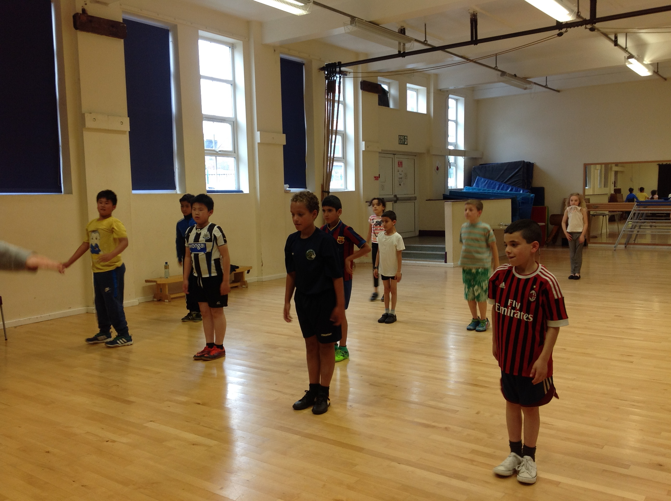
The ground floor provides a reception area, the school office and a community room. Our school gym, dining room and Early Years Unit, consisting of our nursery and reception classes are also located on the ground floor. The school is linked to the church hall through the gym.

The gym

The first floor has five classroom areas, the school library and the Information Technology room which the children use regularly to enhance their computer skills. The first floor also contains a literacy room, staff room and community room which are regularly used by parents and local groups.

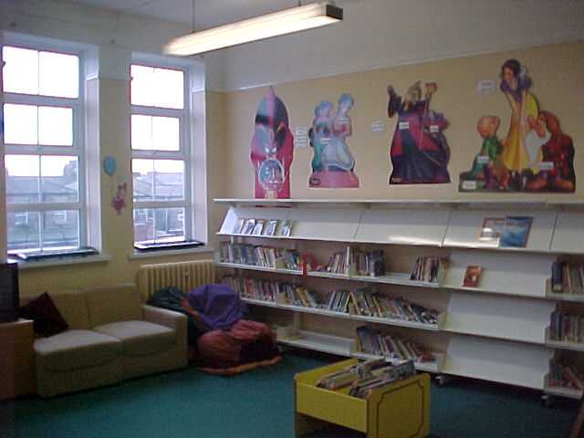
The exterior of the building is well cared for and was repainted in summer 2004. To the south of the building is the Early Years play area which includes climbing frames, slides etc, all built on a safety surface. The main school yard is also divided into three sections, a well maintained garden area where children can sit quietly or read, an inner yard in which ball games are not permitted and a large outer yard where children can play football etc. The library

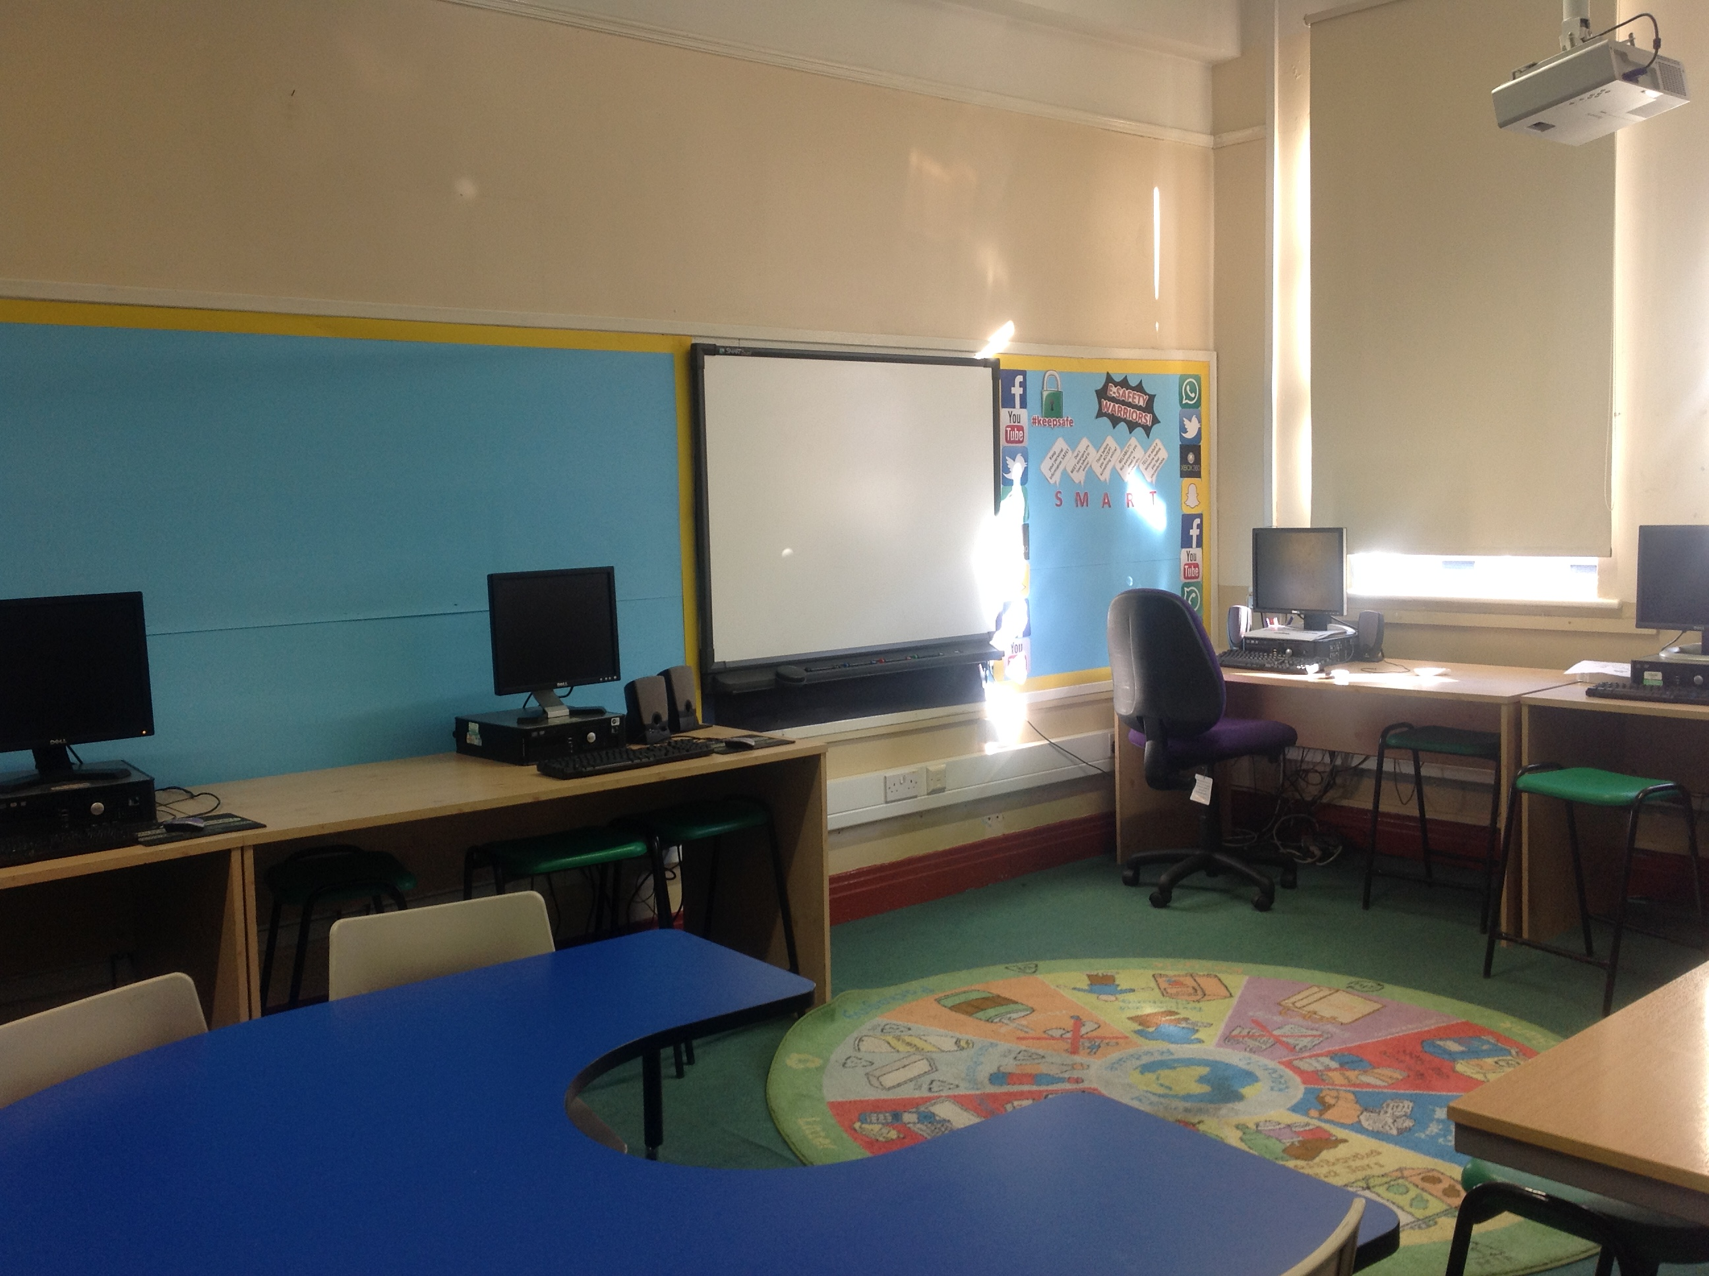
A timber trail, games areas and traversing wall ensures increased physical activity during breaks and prevents boredom. The perimeter fence has also been replaced [April 08] increasing security for the pupils as well as the premises.

The ICT Suite

SCHOOL INFORMATION

School starts 8.55 am

Break 11.00 - 11.15am KS1 & 2

Lunch 12.00 – 1.00pm Early Years
12.15 – 1.00pm KS1 & 2

Afternoon break 2.15 - 2.30 pm KS1 only

School ends 3.00 pm Early Years
3.15 pm KS1 and KS2

CLASS ORGANISATION
All staff get to know children in school very well as classes are small. This gives your child more opportunity for individual attention and personalized learning.

Most classes are mixed ability with children being taught a full range of National Curriculum subjects by their class teacher.

Some interchange of staff does occur to take advantage of the particular skills of teachers, for example Music or PE.

During the current academic year the school is organised as follows:
- Early Years
- Year 1
- Year 2
- Year 3
- Year 4/5
- Year 5/6

ADMISSIONS

Children are admitted to the school in the September of the school year in which their fifth birthday falls. The standard number of children for each year group is 20.

There is no formal catchment area for the school, places being allocated upon
a parental preference basis.

The Governing Body reserves the right to consider each application on its own merit.

Appeals Procedure
A copy of the school's appeals procedure is available from the Head Teacher.

School Clothing
We want to develop a strong sense of belonging to Christ Church C E Primary School. This is more easily achieved when the children can identify with the school colour and logo. We encourage all pupils to wear our school uniform.

Girls Uniform | Boys Uniform | PE Kit
Navy blue/Dark grey skirt/ trousers | Navy blue/Dark grey trousers | T Shirt
White polo shirt | White polo shirt | Shorts or jogging pants
Navy blue sweatshirt/cardigan | Navy blue sweatshirt | Sandshoes or trainers

Sweatshirts (with the school logo), polo shirts and a PE kit can be ordered from the school or local supplier and other items are readily available from any major retailers.

For PE lessons children should have a complete change of clothing and appropriate footwear.

Lost Property
To avoid confusion we suggest that children have their names either written or stitched into all items of school clothing.

The school cannot be responsible for the loss of any clothing or personal belongings.

Toys should be left at home.

Jewellery

The school discourages the wearing of jewellery in school. Not only is it easily lost, but items such as ear-rings are potentially dangerous.

No jewellery is to be worn during PE lessons for obvious safety reasons.

Teaching and Learning
At Christ Church every child matters. Teachers ensure that activities help children to:

- be healthy;
- be safe;
- enjoy and have fun;
- achieve and progress;
- and to become active citizens.

We also place great importance in children being independent learners.

The Curriculum
At Christ Church we offer a broad, balanced and differentiated curriculum. All children receive daily lessons in Mathematics and English.

The school is at present reviewing its schemes of work in order to deliver a more creative and motivating curriculum.

In addition, we are increasing the use of resources in the local area to enhance the curriculum, for example, The Stephenson Railway Museum, Whitehouse Farm and The Discovery Museum.

We are also seeking to make use of cross curricular links between various subject areas using key topics and themes, e.g. Land of the Dinosaurs.

Visits out of school

We believe that learning in the local area offers valuable enrichment opportunities and so we maximize opportunities. Children will frequently go on visits out of school. This may be to museums, exhibitions and the theatre. Whenever your child leaves school we ensure that there is adequate supervision and risk assessments are carried out.


For visits in the local environment not requiring transport we will ask you to give permission once per year. Other visits involving transport will always require your written consent.

English

All children in years 1 – 6 have a daily English lesson. In addition literacy is taught creatively through other subjects, e.g. non-chronological reports in science. Handwriting (Penpals), guided reading and phonics/spelling are also taught as additional literacy sessions.
We also incorporate Talk for Writing and Big Writing which provides opportunity for writing at length.
Our main reading scheme is Storyworlds OUP and we use a combination of phonics teaching including Letters and Sounds and Jolly Phonics.

Key Stage 1
Activities include:
- reading nursery rhymes and traditional and modern rhymes and poems;
- reading short stories and big books;
- developing understanding of texts, asking and answering questions, predicting and commenting on texts read;
- using simple dictionaries;
- learning to use a contents page, an index and a glossary;
- reading and writing recounts, instructions, non chronological reports and explanations;
- reading stories and poems from other cultures;
- writing own stories and poems based on texts read.

Key Stage 2
Activities include:
- reading and writing myths, legends, parables and fables;
- reading narrative from other cultures;
- using a dictionary and a thesaurus;
- using directories and encyclopedias;
- reading, performing and writing playscripts;
- reading and writing a variety of poems, e.g. shape poems, sonnets, narrative poems;
- reading and writing recounts, report, explanations, newspapers, instructions, explanations, discussion and persuasive texts;

- comparing the work of different authors and poets.

Speaking and listening, reading and writing are not only interdependent but mutually enhancing. Speaking and listening skill are taught explicitly in literacy and developed throughout the curriculum.

Mathematics
Each day the children take part in a daily mathematics which usually begins with mental and oral skills.
During the main part of the lesson the teacher teaches key concepts; the children may work as a whole, in groups or individually.

The plenary at the end of the lesson, allows the children an opportunity to review and consolidate what they have learned.

In Key Stage 1 & 2 units of work are:
- number and place value;
- addition, subtraction, multiplication and division;
- fractions;
- measurement
- geometry and statistics.


In Key Stage 2 additional units of work are:
- ratio and proportion;
- and algebra.

Computing
All children have access to ICT and have at least 1 weekly lesson in the ICT suite. Every classroom has an interactive white board which is used throughout the day by pupils and the teacher. Ipads are used regularly throughout the school.

As children move through school they develop skills in computing, learning how digital systems work and how to put this knowledge to use through programming.


Science
Great importance is placed on practical work and using our senses to investigate and explore the world around us. At Christ Church we encourage children to work in a scientific way. This involves:
- Observing and investigating
- Planning, hypothesizing and predicting what will happen
- Making a fair test
- Interpreting results
- Communicating what they have done and found out.



History
The study of history takes place through a variety of units of work.
In Key Stage 1, the units of work allow the children to compare the present with the past. Topics include:
- Toys
- Seaside Holidays
- Transport
- Homes


They also study some famous people and events which include:
- Florence Nightingale & Mary Secole
- Grace Darling
- The Great Fire of London

In Key Stage 2, children develop knowledge and understanding of the following periods in history.
- Invaders – The Romans, the Vikings and the Anglo-Saxons
- Ancient Egypt
- The Ancient Greeks
- Ancient China – The Shang Dynasty
- The History of Baghdad (early Islamic Civilization)
- The Lives of Victorian Children
- Voyages of Discovery
- Children in World War 2

Children are taught to identify different ways in which the past is remembered and how to use sources to find out about the past. They develop their chronological understanding and increase their historical vocabulary.

Geography

The children learn about the local area, their country and localities overseas. We are increasing the study of places world–wide to reflect the cultural diversity of pupils in school.

Studies develop the children’s awareness of place, of physical and human geography and environmental change. Children develop geographical skills using maps, atlases and aerial photographs.

Skills are further enhanced on field visits in the local area, e.g. Whitehouse Farm, the River Ouseburn.

Design Technology
In DT children are encouraged to be inventive, designing practical solutions to problems and exploring how things are made.

Children have experience of working with a variety of tools and materials including cooking and working with textiles.
Art & Design
In art the children investigate and experiment with different media, tools and techniques.

They develop their knowledge and understanding of designers, crafts people and artists from this country and other cultures.

Sport & PE
Physical activity plays a big part in teaching and learning at Christ Church.
Throughout the day children take part in brain gym which helps maintain concentration and develops a healthy body and brain.

During PE lessons the children develop skills which enable them to play a variety of sports, e.g. football, rounders and netball.

Throughout the year we have specialist coaches who promote an even greater range of sports, e.g. basket ball and tennis.


In years 3 and 4 children have the opportunity to learn to swim.

We have also developed links with the Falcons Rugby club and the Newcastle Eagles Basketball Team.


In addition, we employ a sport coaches who teaches football skills during the lunch breaks. We have a school football team and compete in several tournaments.

To develop outdoor educational skills the children in either Year 5 or 6 are taken on residential visit where they have the opportunity to develop skills in archery, climbing and orienteering.

Religious Education
Religious Education is taught in line with the Newcastle Diocesan Syllabus with a strong emphasis on Christianity.

Other beliefs are explored and the children are able to handle artifacts from other world religions.

 We have close links with the church attending carol and Christingle services.

We regularly take part in national and local fund raising events, including Christian Aid and Shelter

Collective Worship
Although other faiths may be mentioned in collective worship these times are predominantly Christian based.

Religious Education &
Collective Worship
Whilst we would like all children to be fully involved in all areas of school life, including Religious Education and acts of collective worship, we also recognise and respect the beliefs of those parents and children who are followers of other faiths.

Parents are able to exercise their rights to request the withdrawal of their children from Religious Education and acts of collective worship.

Music
Singing and performing is very important to Christ Church. Whole school performances take place at Easter and Christmas. Year 6 have an annual leaver’s performance.


Teaching is based on the National Curriculum Programmes of Study. Experiences include singing, listening to live and recorded music and playing instruments.

In KS2 children have the opportunity to learn to play the recorder and
the clarinet. We also have an after school drumming club.


During the year the music curriculum is enhanced with visiting musicians and workshops, e.g. African drumming, provided by the Newcastle Music service.

At Christmas we try to ensure that all children in KS 2 are taken to the theatre to see a pantomime.

Personal, Social, Health & Cultural Education - PSHCE
We believe that our school can play an important part in helping children develop healthy lifestyles and prepare them for playing an active role as a good citizen.

Personal, social, health education and citizenship are developed in discreet PSHCE sessions, through other subject areas, as well as circle time, collective worship, and drama.

Views from children are sought regularly and we also have a school council which meets half termly. The meetings allow the children to look at how we can make our school a better place. Suggestions and ideas by the children are taken to the staff and governors for consideration and action.

The school is a health promoting, smoke free place. We look at exercise, food and nutrition, keeping safe, personal hygiene and the environment in which we live.

Our work is supported by other agencies in the local area including the school nurse and Nexus.

Pastoral care
The immediate responsibility for each child’s welfare is with the class teacher.

Mrs Jones-Wright also has a pastoral role and can provide additional support and guidance. The head teacher is available too.

In addition, the school employs a counsellor to support individual children.

In the case of accidents, our First Aiders are on hand to give support and first aid care.

Sex Education
As part of our science and health education scheme of work, we include teaching on the human body and human reproduction.

Sex education is appropriate to the children’s age and understanding. It is presented within a moral family orientated framework. We are supported in this work by the school nurse.
Equal Opportunities
As an Anglican school, based on the Gospel and teaching of the Church, we hope to foster commitment to the equality of all people in the eyes of God. With this in mind we, as a school, are pledged to the combating of all discrimination.

All children whatever their background, religion, culture, race or need are treated fairly and equally.

We have a zero tolerance of all discriminations.



Out of hours activities
The school offers a range of after school clubs. They provide additional opportunities for children to participate in sport, dance, computing and the arts.


The homework club provides an opportunity for children to be supported with work set by their teacher and the computer club ensures children have access to computers and the internet.


Clubs may change from term to term to ensure all children’s interests are catered for and also to maintain interest. We request a small donation towards the clubs, usually £2 per term.

We also have a breakfast club [free] which is open at
8.00-8.55am Monday to Friday.

We have a multi-skills club Monday – Thursday 3.00-5.00 - £5 per session.

Homework
The school follows the DfE (Department for education) guidelines for the amount of homework given, which are as follows:

Year 1-2 - 1 hour per week
Year 3-4 - 1½ hours per week
Year 5-6 - 2½ hours per week

Children in the Early Years will also be given homework tasks such as learning letter sounds or home reading.

As a school we believe that we should form a partnership with parents with both working together in the best interests of our children. For this reason we hope that all parents of our pupils will understand the importance of homework and support the school as it aims to develop each child to their full potential.

English as an additional language [EAL]
Children who speak English as an additional language are provided with support when needed by either our inclusion teacher Mrs Power and/or a teaching assistant.

We have a programme of work for children who have no English to complete when they first enter our school.

We are continuously expanding our multi-cultural resources and making our curriculum more inclusive. We have many dual language texts in our school library.
Gifted and talented
At Church Church we consider all children have a smart and take time to identify every child’s particular strength, e.g. art, sport, music. We continue to develop these strengths whilst ensuring progress in other areas.

The school recognises that gifted and talented children also have particular needs. A policy is in place to ensure that these children are identified and challenged through programmes of work appropriate to their levels of ability.

Special Educational Needs
We recognize the fact that all children are different. Some children have learning difficulties and disabilities [LDD]. We value the achievements of all children and we are committed to providing the best learning conditions to enable all children to reach their potential.

The cycle of assessment, observation, provision, monitoring and review is carried out in partnership with the Special Educational Needs Co-ordinator[SENCO], parents, the class teacher and the child. Targets are recorded on an individual educational plan which is reviewed termly.

Sometimes it may be necessary to involve the support of outside agencies i.e. Educational Support Service, Educational Psychology Service. The SENCO will make the appropriate arrangements and seek parental consent.

Extra help can be given to children who require it through the use of support packages delivered by our specially trained classroom assistants and nursery nurses. Parents are kept fully informed at all stages and are invited into school on a regular basis to review their child’s progress.


Discipline and rules
At Christ Church we seek to develop positive attitudes and self discipline amongst our pupils. Our behaviour policy places heavy emphasis on rewarding good behaviour and modifying inappropriate behaviour. We expect parents to support the school and work in partnership with us to ensure that behaviour within our school is of a high standard. School rules are kept to a minimum and are displayed around school so that children have a complete knowledge and understanding of what is expected of them. Our rules at Christ Church are as follows:

Golden Rules
- Respect our school, its people and its property
- Treat other people the way that you want to be treated
- Reach for the stars


As already mentioned our aim is to modify any inappropriate behaviour but the school will take action in the case of serious or persistent misbehaviour. In such cases the parents will be requested to make an appointment with the head teacher to discuss the behaviour of their child and the action to be taken. The school reserves the right to exclude pupils who are guilty of the most serious breaches of school discipline although this will be used as a last resort.

Anti-bullying
We want the children to feel safe and enjoy school. We encourage the children with adult help to solve problems. At playtimes and lunchtimes we have buddies to support children and identify any problems. Buddies also look after reception children when they first transfer to the bigger yard.

In cases of bullying, parents will be requested to come to school to discuss individual incidents. Bullies will be closely monitored and provided with support to enable them to change their behaviour. Persistent bullying may lead to exclusion.

Child Protection / Safeguarding
Schools have a huge responsibility for the welfare of children. The staff at Christ Church C E Primary School, take that responsibility very seriously.

We have a safeguarding policy which states how we can help children protect themselves. The policy also states the procedures we must follow in the event of a child making a disclosure.

Parents, carers and other adults may approach the school with information or for support. If teachers are concerned about a child, if there is a concern about an injury, neglect or sexual abuse, that concern must be registered with the appropriate authority.

We are not investigators but we do have an important role to play in the referral process. The head teacher is responsible for child protection.

Home-school Partnerships
It is vital that there are frequent and good communications between school and home.
Contact can be verbal, written and through meetings and workshops.

An achievements assembly is held every Friday morning at which children are rewarded for good work etc. Parents are invited to attend this event and then to meet in the Community room for coffee and participate in various discussions. Parents are able to use our community room at the beginning and end of the school day if they wish to.

Parents also play a valuable role in organising and assisting at fund raising events and many assist on educational visits and in school.

The school holds open evenings where parents can come into school to discuss their child’s progress with the class teacher. Teachers are also willing to do this at other times but it is advisable to organise an appointment before the school day begins or at the end of school day. Children’s educational targets are shared with parents and children throughout the year.

The head teacher is also readily available to meet with parents both at the beginning and end of the school day. Parents who wish to discuss matters of a private nature also have the opportunity to arrange an appointment with the Head Teacher.

At the end of each school year parents receive a written report on their child’s progress.

Term | Event
Autumn Term | Meet & Greet  Progress Meetings | Meet teacher / short presentation by class with information about new topics etc  Opportunity to discuss how children are settling in and share targets
Spring Term | Progress Meetings | Opportunity to view children’s work  and discuss targets and progress
Spring Term | KS 1 & 2 SAT meeting | Opportunity for parents to be more informed about SATs, seek advise  and clarify issues.
Summer Term | Optional individual appointments  for parents | Opportunity for parents to discuss report and raise individual issues
Summer Term | EYFS Open Day | Opportunity to meet staff and visit  the EYFS unit

Links with the community
We encourage the children to work in the wider community and we have close links with the church and residential homes in the area.

The school has used Newcastle United FC, Newcastle Eagles Basketball Club and Newcastle Falcons Rugby Club in the last couple of years to improve the support we provide for our children.

We also have connections with Young Enterprise and Family Learning.

Throughout the year the school participates in fund-raising events for the local community, e.g. carol singing in Eldon Square.


Home-school Agreements
We have a Home-School Agreement in place. A copy of our Agreement is enclosed and has been produced after consultation between staff, governors and parents.

The school will ensure that it keeps to its part of the agreement and in return expects parents to do likewise.

We see this as another vital link in the partnership between parents and school as we work together for the benefit of our pupils.

Friends of Christ Church
The school has a group of parents who meet termly and organize fund raising events. Money raised helps pay for workshops and visits in the local area. This is a successful group who welcome new recruits. Please join.


Absences
At Christ Church we emphasise the value of prompt and regular attendance. Consequently we would appreciate parents co-operation in ensuring that wherever possible dental/medical appointments take place outside of school hours and that children are not absent for trivial reasons.


We do accept that in the event of serious illness, children will need
to take time off school. When these occasions arise we would appreciate
a telephone call to inform us of the reason for the absence.

This means that the absence is then authorised and will consequently avoid the necessity for the school to contact its attached Education Welfare Officer.

School Holidays
In September we provide a list of all school holidays and training days.

We do not authorize holidays during term time except in exceptional circumstances.

It is vital children come to school every day especially in May when children in Years 2 and 6 take national tests [SATS].

School Meals, National Fruit scheme and Milk
Children in Nursery to Year
2 receive a free piece of fruit daily.


Children in nursery also receive free milk. Both these initiatives are funded by the government.

Children can either eat a school lunch or bring a packed lunch. Dinner money should be brought into school in an envelope, preferably for the whole week on a Monday.

School lunches are free for children in Reception, Year 1 and 2.

No sweets are allowed in school.

 | 2015/16 | 2016/17 | 2016/17
Attendance | 94.9 | 96.2 | 95.1
We would like to increase our attendance.

Health and Safety
The school obviously believes that the health and safety of children is of vital importance. Our school rules (see earlier) are not only designed to maintain good discipline but also to keep children safe. The school has a detailed health and safety policy which is available to parents on request. There is a termly fire drill and annual health and safety inspections.

Between the hours of 9.00 am and 3.00 pm (other than at play-times) all doors to the school are secured and the only access to the building is through the main entrance which is protected by a security door and security code. All visitors to school must use this entrance and sign both in and out. These procedures emphasise that we take the safety of our children extremely seriously.

At various times throughout their time in school, your child will undergo basic medical tests for hearing and sight which will be administered by trained medical staff.

Whilst in Reception your child will probably have an eye and hearing test and be weighed. The school also works closely with its attached school nurse who will also be willing to arrange an appointment with you to discuss confidentially, any concerns you may have regarding your child’s health.

A member of staff [a named first aider] will administer medication (e.g. inhalers) providing an appropriate form is completed by parents. It is also essential that parents understand that the school staff are not trained medical practitioners and therefore have the right to refuse to administer medication.

In school, any minor accidents are treated by staff who are qualified in basic first aid. The class teacher will inform you at the end of the day of any minor incidents and any treatments administered. In the case of a more serious accident or illness we may need to inform you immediately.

Consequently it is vital the school has a contact, telephone number for yourself (home and work if appropriate) and a trusted friend, relative or neighbour.

In the case of not being able to contact you after a serious accident, the school reserves the right to take your child for immediate medical treatment whilst further efforts are made to contact you. Obviously, in the case of serious treatment being required then the hospital would need your permission to proceed which emphasises the need for us to have up to date records so that we can contact you quickly in the event of an emergency.


Complaints Procedure
In the event of a complaint arising about the school or a member of staff, the head teacher should be the first point of contact. If the matter cannot be resolved then the governors will become involved.

A copy of the school’s complaint procedure is kept in school.

Keeping and Disclosure of Pupil Records
Parents have a right of access to children’s records upon written request to the head teacher.



TO SUM UP
This is your school. We hope this booklet will have answered any questions you may have and will have given you all the information you require. If there is anything you are not sure about, or anything which you feel we have not told you, please don’t hesitate to get in touch.

Everyone at Christ Church looks forward to welcoming you to our school.

Disclaimer
All details in this brochure were correct at the time of going to print.

