 | Week 2 YEAR 6
 | Learning | Activities
English | Talk 4 Writing  Writing information texts.  Creating formal / informal sentences. | https://soundcloud.com/talkforwriting/swamp/s-28ED2KJCK6n  Listen to the audio and then complete the talk for writing activities 2 & 3 (up to page 5).  https://www.talk4writing.com/wp-content/uploads/2020/06/Y6-Monsters.pdf
Mathematics | BBC Bitesize Lesson:  Multi-step addition and subtraction problems | Complete week 1 challenges to see how much you remember from last week.  https://www.bbc.co.uk/bitesize/articles/zhvx6v4  Now moving onto mutli-step addition and subtraction problems.  https://www.bbc.co.uk/bitesize/articles/z6ynscw  Click on the link and watch the videos/presentations, read explanations and apply skills through the practice activities. Where possible can you use the ‘Bar Model’ method?  (For extra English and Maths activities please use: https://classroom.thenational.academy/year-groups/year-6 )
RE | What is Ramadan? | https://www.bbc.co.uk/bitesize/topics/zpdtsbk/articles/zjc2bdm  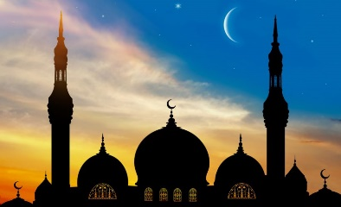  Watch the video and then the presentations. https://www.bbc.co.uk/bitesize/clips/z434wmn  Have a conversation with a family member or friend who is Muslim. Talk and ask about how they celebrate Ramadan. Write up your conversation.
History | What was Baghdad like? | Look at aerial views and plans of Baghdad – built as a circular city with four gates.  Google Image search. https://www.google.com/imghp?hl=en  Write a description of the original layout of Baghdad.
Art/DT | Islamic Art  Geometric patterns | Google and research Islamic Art.  Look at a range of patterns from Islamic art. What do the children notice? - Islam does not use holy images or visual symbols.  Research what does geometric mean?  Create your own Islamic art geometric pattern/patterns.
PE | Joe Wicks PE lesson  Premier League Stars | Complete daily sessions with Joe Wilkes.  https://www.youtube.com/playlist?list=PLyCLoPd4VxBuq8B38fVvu7Xmhlc_8PFVY  Complete the weekly challenge.  https://plprimarystars.com/resources/super-movers-celebration-challenge  Once you have completed this, you can try and of the other previous challenges through the link below.  https://plprimarystars.com/news/friday-family-challenge

