 | Year 2 - Week 8
 | Learning | Activities
English | Seaside poems  Can you write a sense seaside poem?  Can you include all of the senses?  Can you include some alliteration?  Can you set it our like a poem with each sense on a new line? | Read the poems form last week. Focus on the seaside senses poem.  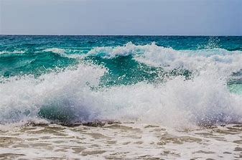  Plan your own seaside senses poem e.g. I can see……..  I can hear……..  I can smell………  I can feel………  I can taste………..  Include some alliteration in your poem e.g. fabulous fresh fish,  Share your poem with your family.
Mathematics | Can you name the coins?  Can you recognise the shape, colour and size of coins?  What coins can you use to make a total? | https://www.bbc.co.uk/bitesize/articles/z6tv382  Sort the coins by shape, colour, size and value.  https://www.bbc.co.uk/bitesize/articles/zn4q7nb  Make a pretend shop using your toys, make your own prices. Can you use coins real or drawn to buy your toys? What different coins can you use?
Science | What do humans need to keep healthy? | https://www.bbc.co.uk/bitesize/clips/zw3jxsg video  https://www.youtube.com/watch?v=UxnEuj1c0sw video  Make a keeping healthy poster or leaflet.
Geography | What makes the seaside or Newcastle a special place to visit? | Make a leaflet or poster advertising the seaside or Newcastle  What will people enjoy doing or seeing at the seaside or Newcastle?  E.g. St James Park, walk along the Quayside, the castle, restaurants, swimming pools, shops, Granger Market,  Seaside – St Mary’s Lighthouse, chip shops, amusements, ice-cream shops, beaches,
Art/DT | How will you make your pirate ship? What will you need? How will you join and decorate it? | 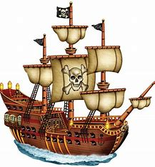  Make your pirate ship using your plan from last week.  Join the materials together and decorate it.  Or make a pirate ship out of Lego or anything you have!  Design and make a pirate ship flag.
PSHE | What might have happened to the whale? How did the boy feel?  How can we protect whales and animals? | https://www.youtube.com/watch?v=nR4rzqsaiyA story My friend whale  http://www.wdcs.org/wdcskids/en/savewhalesanddolph.php Whales and Dolphins conservation
PE | Can you follow the instructions?  Can you achieve the challenges? | https://www.youtube.com/user/WestYorkshireSport/videos  #THISISPE - Short PE lessons every Monday, Wednesday and Friday. Challenges to do at home without specialist equipment.
Computing | Can you type up your poem and use some seaside images? | Type up your seaside senses poem from English and add some seaside images. Can you change the size and colour of the text?

