 | Year 2 - Week 7
 | Learning | Activities
English | Seaside poems  Can you recite a seaside poem by heart?  Can you find words that rhyme?  Can you find some alliteration?  Which is your favourite poem? Why? | 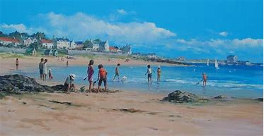  Read a range of seaside poems, some websites below  http://www.brendawilliamspoet.co.uk/Treasures.html  http://www.angelaspoems.webeden.co.uk/seaside-senses/4539518546  https://venngage.net/p/240455/seaside-poem-by-shirley-hughes-worldpoetryday  http://www.brendawilliamspoet.co.uk/Footprints.html  http://members.abcteach.com/members/coralreef_oceans/oceans2.pdf  Can you add actions to the poems? Can you learn a poem by heart?  Can you find any words that rhyme? E.g. shells and bells  Can you find any alliteration? E.g. shiny, shimmering shells  Which poem do you like the best? Why?
Mathematics | How many different ways can you make a number?  Which is and odd number? How do you know?  What doe you know about odd and even numbers? | https://www.bbc.co.uk/bitesize/articles/z7cthbk Show a number in a range of ways, using objects and pictures, how many different ways can you make a number? E.g. 45 40 + 5 or 25 + 20, How else could you make it? Try 3-digit numbers too.  https://www.bbc.co.uk/bitesize/articles/zr23c7h sort numbers into odd and even. What do you notice about odd and even numbers?
Science | What is a food chain?  I can draw and explain food chains. | https://www.bbc.co.uk/bitesize/clips/z96r82p video  https://www.bbc.co.uk/bitesize/clips/z8hxpv4 video  https://www.bbc.co.uk/teach/class-clips-video/science-ks1-the-food-chain/zbr8d6f video
History | How have seaside holidays changed? | https://www.peacehavenheights.co.uk/attachments/download.asp?file=2289&type=pdf  Write a report using sub-headings, make a fact file or poster.
Art/DT | What do pirate ships look like? What shapes and colours are they? What parts do they have? | 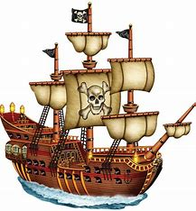  Design a pirate ship and identify junk materials you will use e.g. tubes, boxes etc.  OR make a pirate ship out of Lego.  Design and make a pirate ship flag.
PSHE | How can we look after different animals in our world?  What is Greenpeace? | Read Dear Greenpeace - Michael Foreman. – Make a leaflet about Greenpeace  https://www.greenpeace.org.uk/about-greenpeace/  https://www.slideshare.net/LouiseVanLaar/dear-greenpeace
PE | Can you follow the instructions?  Can you achieve the challenges? | https://www.youtube.com/user/WestYorkshireSport/videos  #THISISPE - Short PE lessons every Monday, Wednesday and Friday. Challenges to do at home without specialist equipment.

