10/10/2025

Dear Parents and Carers

We would like to invite all parents and carers into school for a Meet and Greet Assembly on Friday followed by an opportunity to visit your child’s classroom. Each class will do a short presentation giving you information about the school and their class. We hope you will be able to join us.

Other opportunities to visit school are noted below.

YEAR | Event | Date | Time | Place
Years 1-6 | Meet and Greet | Friday 17 October | 8.55am | School hall
Whole school |   Harvest Festival | Friday 24 October | 8.55am | School hall
Nursery and Reception  Years 1-6 | Parents Evening | Tuesday 11 November | 2.30-5.30pm | Classrooms
Whole school |   The Nativity | Friday 19 December | 8.55am | School hall

Weekly Friday Achievers Collective Worship 8.55
Parents are welcome to attend our weekly Friday Achievers Collective Worship 8.55 in the school hall. We usually play a short information video about what the children are focusing on this term, e.g. e-safety, protected characteristics etc between 8.45 and 8.55 whilst we wait for the children to complete registration.

School Uniform and PE Kits
Thank you for supporting the school uniform policy. Almost all children wear a school sweatshirt with the school logo. Most children are also wearing a navy tracksuit for PE. Please speak to Mrs Scott if you need support in purchasing a tracksuit. We have some sizes in stock.
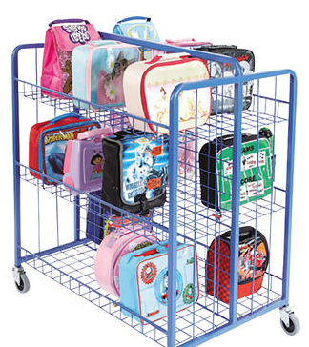
Packed Lunch Boxes
Please make sure packed lunches are brought to school in a packed lunch box. Back packs and other bags are too big for our storage trolley.

Enjoy the weekend.
Mrs Furno
Headteacher

