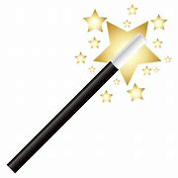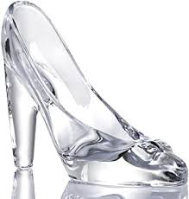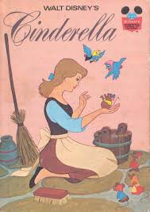

**Writing Ideas**

* **Write a party invitation to the ball – remember to include place, date, time.**
* **Write a story map of Cinderella (make sure you have a beginning, middle, end)**
* **Draw your favourite character from the story (Cinderella, Prince Charming, wicked stepmother, ugly stepsisters, or the fairy godmother).**
* **Write some words to describe your character. Can you write a sentence about them?**

**Week 5 ‘Cinderella’**

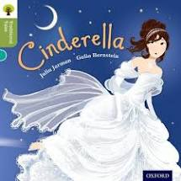

You can find a reading of this book on

YouTube – ‘Cinderella’

**Other Ideas**

* **Design a new shoe for Cinderella**
* **Create a wanted poster for the girl who fits this glass slipper for Prince Charming.**
* **Build a castle for Cinderella (e.g. out of junk modelling or Lego/ Duplo).**
* **Plant some pumpkin seeds at home.**

Maths Ideas

* Collect pairs of shoes from family members. Who has the biggest feet in your house? Who has the smallest feet? Can you put the shoes in size order?
* Measure the fairy godmothers magic wands (sticks you might find outside or in a garden) from the shortest to the longest.

**Phonics/Reading Ideas**

* Sequence and re-tell the story of Cinderella.
* Cut and stick the sentence building cards to build a sentence.
* Read simple sentences e.g. The fairy godmother turns a pumpkin into a coach. Encourage your child to sound out words e.g. c-oa-ch.