The funding has been provided to ensure impact against the following OBJECTIVE:
To achieve self-sustaining improvement in the quality of PE and sport in primary schools. It is important to emphasise that the focus of spending must lead to long lasting impact against the vision (above) that will live on well beyond the Primary PE and Sport Premium funding.
It is expected that schools will see an improvement against the following 5 key indicators:
Evidencing the Impact of Primary PE and Sport Premium
Christ Church CE Primary School

Vision for the Primary PE and Sport Premium
ALL pupils leaving primary school physically literate and with the knowledge, skills and motivation necessary to equip them for a healthy, active lifestyle and lifelong participation in physical activity and sport
- the engagement of all pupils in regular physical activity – kick-starting healthy active lifestyles
- the profile of PE and sport being raised across the school as a tool for whole school improvement
- increased confidence, knowledge and skills of all staff in teaching PE and sport
- broader experience of a range of sports and activities offered to all pupils
- increased participation in competitive sport

Under the Ofsted Schools Inspection Framework 2015, inspectors will assess how effectively leaders use the Primary PE and Sport Premium and measure its impact on outcomes for pupils, and how effectively governors hold them to account for this. Schools are required to publish details of how they spend this funding and the effect it has had on pupils’ PE and sport participation and attainment.
Revised September 2016

Schools must include the following:
- how much PE and sport premium funding you receives for this academic year
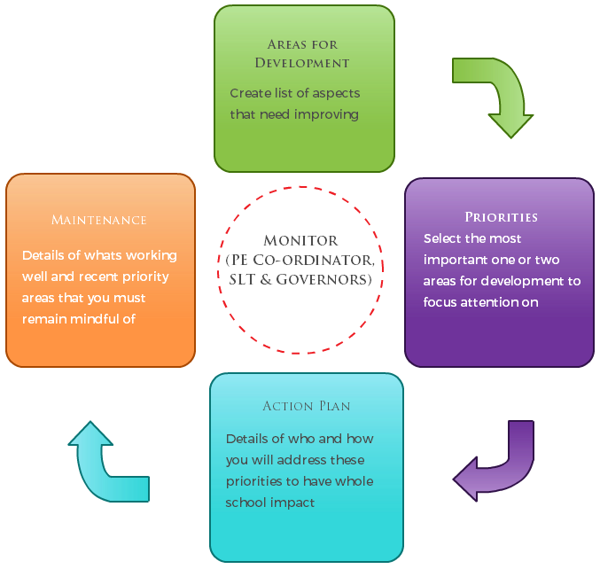
- a full breakdown of how you’ve spent or will spend the funding this year
- the effect of the premium on pupils’ PE and sport participation and attainment
- how you will make sure these improvements are sustainable
The published information should be clear and easily accessible and we recommend that you upload the following template (Annex 1) to your website for this purpose.
Improvements should enhance, rather than maintain existing provision. For example, where schools are using their funding to employ specialist coaches, these should be deployed alongside class teachers rather than displacing them, in order for their impact to be sustainable and to enable the upskilling of existing teachers.
Primary PE and Sport premium planning and actions should show how use of funding contributes to this vision through identified school priorities which can be measured through reference to key outcome indicators. It is important that the main drivers for improvement are those identified by the school through their self-review. Each school should aim to achieve the following objective:
OBJECTIVE: To achieve self-sustaining improvement in the quality of PE and sport in primary schools. Please see Figure 1 (above): A process model to support your thinking.

HOW TO USE THE PRIMARY PE AND SPORT PREMIUM
Schools must use the funding to make additional and sustainable improvements to the quality of PE and sport they offer. This means that you should use the premium to:
- develop or add to the PE and sport activities that your school already offers
- make improvements now that will benefit pupils joining the school in future years
For example, you can use your funding to:
- hire qualified sports coaches to work with teachers
- provide existing staff with training or resources to help them teach PE and sport more effectively
- introduce new sports or activities and encourage more pupils to take up sport
- support and involve the least active children by running or extending school sports clubs, holiday clubs and Change4Life clubs
- run sport competitions
- increase pupils’ participation in the School Games
- run sports activities with other schools

You should not use your funding to:
- employ coaches or specialist teachers to cover planning preparation and assessment (PPA) arrangements - these should come out of your core staffing budgets
- teach the minimum requirements of the national curriculum – including those specified for swimming.
Guidance on the primary PE and sport premium can be found at gov.uk.
Annex 1 – Primary PE and Sport premium – Online reporting template
Name of school: Christ Church CE Primary School
SECTION 1A – EVALUATION OF IMPACT/LEARNING TO DATE
Academic: 2016-2017
In previous years, have you completed a self-review of PE, physical activity and school sport? Not in detail Yes
Have you completed a PE, physical activity and sport action plan/ plan for the Primary PE and Sport Premium spend? Yes
Is PE, physical activity and sport, reflective of your school development plan? Reference to this document in SDP Yes
Are your PE and sport premium spend and priorities included on your school website? Yes
SECTION 1B – SWIMMING AND WATER SAFETY self rescue focus.

Swimming is an important skill and can encourage a healthy and active lifestyle. All Local Authority schools must provide swimming instruction either in key stage 1 or key stage 2. The programme of study for PE sets out the expectation that pupils should be taught to:
- swim competently, confidently and proficiently over a distance of at least 25 metres
- use a range of strokes effectively [for example, front crawl, backstroke and breaststroke]
- perform safe self-rescue in different water-based situations.
Swimming and Water Safety | Please fill out all of the below:
• What percentage of your Year 6 pupils could swim competently, confidently and proficiently over a distance of at least 25 metres when they left your primary school at the end of last academic year? | Choose an item.%
• What percentage of your Year 6 pupils could use a range of strokes effectively [for example, front crawl, backstroke and breaststroke] when they left your primary school at the end of last academic year? | Choose an item. %
• What percentage of your Year 6 pupils could perform safe self-rescue in different water-based situations when they left your primary school at the end of last academic year? | Choose an item. %
• Schools can choose to use the primary PE and sport premium to provide additional provision for swimming but this must be for activity over and above the national curriculum requirements. Have you used it in this way? | NO
SECTION 2 – REFLECTION: WHAT HAVE WE ACHIEVED 2016/ 2017 AND WHERE NEXT?

Key priorities to date: | Key achievements/What worked well: | Key Learning/What will change next year:
1) Resourcing so we can offer a broad range of sports to target a range of different skills and techniques. This included: netball, hockey and multi-skills.  2) Ensuring children can apply their skills in a competitive environment against children from other schools.  3) Offering sports clubs after school including football and dance.  4) CPD by specialist PE teacher for HLTA who teaches some PE across school.  5) Football coach x5 lunchtimes per week to encourage active participation during lunch breaks as well as developing football skills | Children now have access to a range of sports which will allow for progression of skills throughout the school.  School's participation in competitions and tournaments significantly increased.  The school's football team competed in two leagues, performing very well. The dance club also performed at the Newcastle Dance Festival at the City Hall.  HLTA confidently teacher PE and also extra-curricular sport.  Football very popular during lunch breaks. | We need to ensure these sports are repeated each year so the children's skills are developing. Creating more opportunities for sports clubs will continue this and allow children to focus their interests.  We must give our children more opportunities to compete as they found it difficult to apply their skills whilst in a competitive environment.  The children showed great pride and enjoyment in both of these clubs and the aim will be to add another sport to the after school clubs.

Vision: ALL pupils leaving primary school physically literate and with the knowledge, skills and motivation necessary to equip them for a healthy, active lifestyle and lifelong participation in physical activity and sport.
Objective: To achieve self-sustaining improvement in the quality of PE and sport in primary schools against 5 key indicators:
- the engagement of all pupils in regular physical activity – kick-starting healthy active lifestyles
- the profile of PE and sport being raised across the school as a tool for whole school improvement
- increased confidence, knowledge and skills of all staff in teaching PE and sport
- broader experience of a range of sports and activities offered to all pupils
- increased participation in competitive sport

SECTION 3 – PLANNING YOUR PROVISION AND BUDGET FOR THE COMING YEAR
Use the template below to plan how you intend on spending your Primary PE and Sport Premium funding this academic year, to include which of the 5 key indicators that priority relates to. The greyed out boxes allow you to re-visit this section later in the year to review and plan next steps.

Step by step guidance notes to support completion of the template to achieve self-sustaining improvement in the quality of PE and sport in primary schools:
Step 1: Confirm the total fund allocated
Step 2: Review activities and impact to date either using the template you used last year or section 2 above
Step 3: Confirm your priorities in terms of impact on pupils and enter into column B to detail your school focus (e.g. improved the quality of children’s physical literacy at key stage 1)
Step 4: Cross reference these with the 5 key indicators for the Primary PE and Sport Premium by selecting the aspect(s) that this relates to (e.g. increased confidence, knowledge and skills of all staff in teaching PE and sport) and select these from the drop down menu in column A
Step 5: Complete column C to outline key actions to achieve these outcomes (e.g. whole staff training)
Step 6: Complete column D to detail funding allocated to this priority (e.g. £100.00)
Step 7: Complete column F to show how you plan to evidence the impact of this spend on young people
Step 8: Identify when you will revisit this template to update with actual spend, impact and sustainability next steps (greyed out columns E, G & H)

Academic Year:  2017/2018 |  | Total fund allocated:  £16,000 & £10 per pupil based on Oct 17 census YRS1-6  (£3,531 already received)
A | B | C | D | E | F | G | H
PE and Sport Premium Key Outcome Indicator | School Focus/ planned Impact on pupils | Actions to Achieve | Planned Funding | Actual Funding | Evidence | Actual Impact (following Review) on pupils | Sustainability/  Next Steps
1. the engagement of all pupils in regular physical activity – kick-starting healthy active lifestyles | Targeting children who do not take part in physical activity outside of school, but also allowing access for all, organise an active day at a local leisure centre offering children and families the opportunities to try a range of sports.  Maintain physical activity/sport during the summer holidays.  Purchasing of outdoor gym equipment for the yard to give children more variety of physical activities and also encourage a more active playtime.  More playground markings, e.g. active trail  Purchase additional equipment for use during breaks and lunchtimes.  Purchase out door storage shed for large pieces of outdoor equipment | Offer places to school sport after-school clubs to children known either not to participate or with limited outdoor space in home area.  Ask class teachers to identify children who do not take part in physical activity outside of school.  Ask parents to complete a questionnaire about opportunities in their area.  Check with local sports centres about what they can offer that would impact our children.  Organise trip with sports centre and book bus if necessary.  Liaise with EAL lead and home school co-ordinator to organise a sport day out during the summer holidays  Research age appropriate equipment and install.  Research and order. | £2,000  £300  £300  £2,000  £1,500  £500  £500
2. the profile of PE and sport being raised across the school as a tool for whole school improvement | Using a PE experience for all children that can then be used as a basis for a topic leading into a writing activity.  Incorporate into Safe, Fit and Healthy Week – make it cross curricular, e.g. directions, measurements, scientific investigations, newspaper sport report, interviews. | Work with co-ordinators to plan a mini-topic centred around a sporting theme that the whole school takes part in- similar to the pantomime at the Theatre Royal at Christmas. | Directed time
3. increased confidence, knowledge and skills of all staff in teaching PE and sport | Employing a specialist PE teacher, shared with other members of the OLT, to provide CPD to staff and raise the quality and engagement of PE.  Every member of staff being timetabled to teach at least one term of their own PE so they do not become deskilled.  Refurbishing an old storage cupboard to make it into a changing room for K2 pupils allowing children to change privately and alleviate pre PE embarrassment. | Ensure Diana is working alongside staff in the planning and delivery of their PE lessons and that this CPD is rotated around all staff teaching PE.  Work with SLT to timetable this and provide training to staff where necessary. All staff to teach some PE during the academic year.  EYFS teacher attend training 19/10/17  Work on receiving quotes for the work and action | £3,000  £180  £1,000
4. broader experience of a range of sports and activities offered to all pupils | Provide opportunities for children to attend a greater range of sporting after school clubs.  Continue to further resource PE by purchasing nets and posts for badminton and volleyball.  Experience widening range, e.g. archery, caving, climbing, trapeze, zip wire | Establish netball, hockey and cricket after school clubs (possible rotation) for  both KS1 & 2 pupils to build on the dance and football clubs already offered.  Research and order.  YR5/6 residential outdoor activity centre | £1,000  £2,500
5. increased participation in competitive sport | Continuing to prioritise competitive sport by entering all of the OLT competitions. This will allow children to see the direct link between the learning of skills in their PE lesson to their application in a competitive sporting environment.  An additional netball court marked onto the playground so children can play the sport properly but also host competitive matches against local OLT schools. | Provide transport for all of the OLT competitions.  Embed the school football team founded in 2016/17.  Start an equivalent netball team that would eventually compete in citywide competitions. Purchase team tops.  Continue to organise PE teaching in school so that it coincides with the competitions.  Research and order. | £250  £100  £500
Step 9: The greyed out columns will be useful when reviewing your school’s spend later in the year to confirm actual spend and impact to support further plans for the future and sustainability.
Completed by: Andrew Brown deputy head and PE lead S Furno head teacher
Developed by
Supported by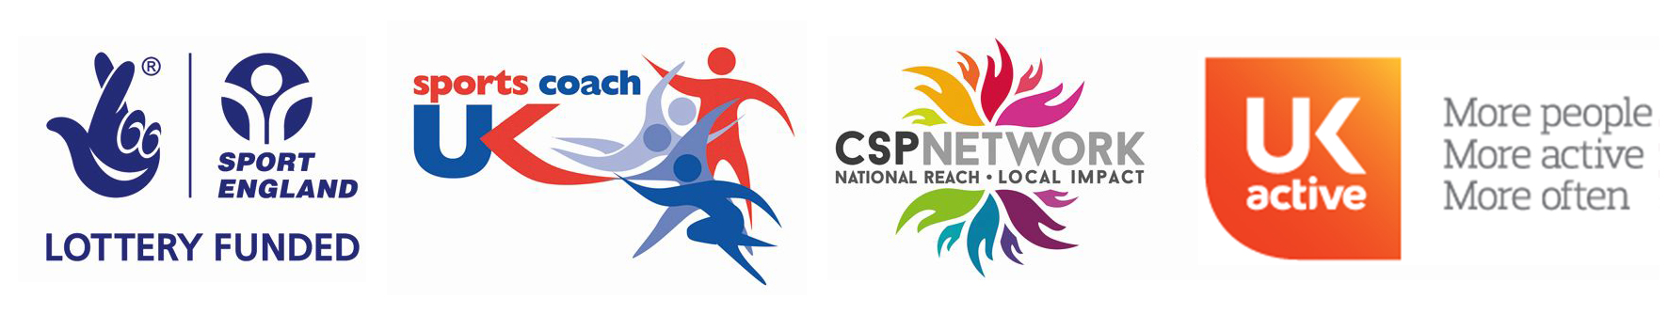

Date: 20/09/2017
Review Date: 20/09/2018
After every update, please remember to upload the latest version to your website.

