This half term we will be:
- Researching the causes and impacts of WW1.
- Exploring:
  - Biography/ Autobiography
  - Private Peaceful by Michael Morpurgo
  - The Witches by Roald Dahl
- Completing a self-portrait project based on Roy Lichtenstein.
- Investigating materials and their properties
- Learning about the importance of e-safety.
- Swimming
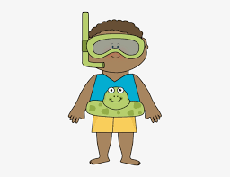

Next half term we will be:
- Researching what life was like during WW1 and understanding the importance of Remembrance.
- Reading:
  - A variety of war poetry,
  - War Horse by Michael Morpurgo,
  - Varjak Paw by SF Said
  - Charlie and the Chocolate factory by Roald Dahl.
- Using maps to investigate the impact of WW1.
- Studying the art of Nash and Nevinson
Participating in the Christmas performance
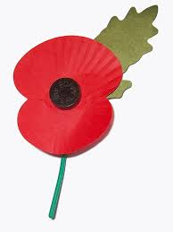
Days for your diary:
Homework will be given on a Monday and should be returned on a Friday. (For project homework, more time will be given)
Home spellings and will be given on a Monday and tested on a Friday.
Children should wear their PE kit to school on a Monday – navy joggers/tracksuit bottoms, white polo shirt, trainers and school sweatshirt.
Bring your swimming kit – swimming trunks/suit and towel on Tuesdays

Help your child with their
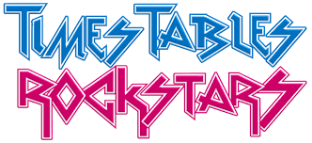
timestables by using:

War, Peace and Celebration
