 | Year 2 - Week 1
 | Learning | Activities
English | Elves and the Shoe Makers  What kind of person was the shoemaker?  Can you describe the three elves?  At the beginning of the story, why was the Shoemaker poor?  Class Book -The Lighthouse Keepers’ Lunch by Ronda and David Armitage's  What events happen in the story?  Who are the characters? | https://www.talk4writing.com/wp-content/uploads/2020/04/Y2-Emma-Elves.pdf  The Elves and the Shoe Maker – Share the story together Page 4-5  Respond to questions page 6-8  Explore word types page 9-10  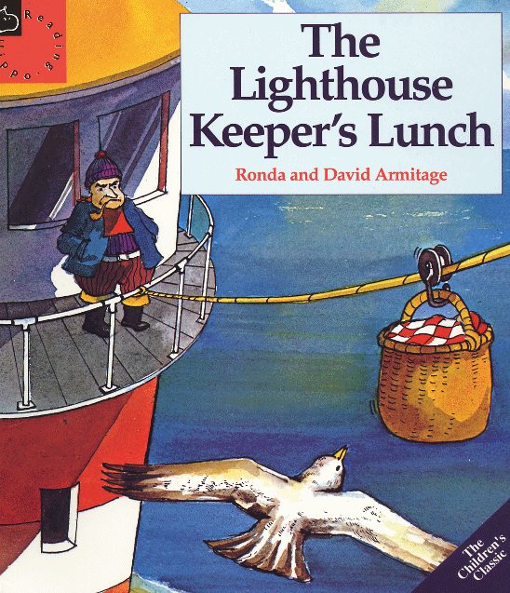  Write a post card from the elves page 12-13  Watch the video of ‘The Lighthouse Keeper’s Lunch’ and talk about the events, characters and setting.  https://www.youtube.com/watch?v=46wCRq50Wwg
Mathematics | Shapes - What are the names of 2D Shapes?  What are the properties of 3D shapes?  How can you sort 2D and 3D shapes? | https://www.bbc.co.uk/bitesize/articles/zq6p7yc  https://www.bbc.co.uk/bitesize/articles/zp2tjsg  https://www.bbc.co.uk/bitesize/articles/zdjtjsg
Science | What are the parts of a plant called?  What are they used for? | Identify plants in garden/ local area and name parts.  Sketch plants and label.  https://www.dkfindout.com/us/animals-and-nature/plants/parts-plant/ labelled picture of parts of a plant and information  https://www.bbc.co.uk/teach/class-clips-video/science-ks1-ks2-ivys-plant-workshop-parts-of-a-plant/zvdkpg8 video about parts of a plant
RE | What makes a place special? | What places are special to you? Why are they special?  Talk, draw or write about a special place. It could be a room in your house, somebodies house you like to visit, a special place you have been to or a favourite holiday place.
Geography | What is an island? What do they all have in common? | https://www.mapsofworld.com/united-kingdom/thematic-maps/uk-islands-map.html map of Islands around the UK, what do you notice about them?  https://www.ducksters.com/geography/islands.php -information about islands  http://www.ks1resources.co.uk/thumbnails-h-1.pdf Katie Morag Island of Coll  Find out about islands and make a fact file.
Art/DT | Where does our food come from? Which food do people eat from the sea? | http://www.greatgrubclub.com/food-from-sea#.XuojgxOSlPY –foods from the sea and information.  Draw and label food which we eat from the sea. Which ones do you eat?
PSHE | Year 2 - PSHE Lesson 3 How are we feeling during lockdown? | https://classroom.thenational.academy/subjects-by-year/year-2/
PE | How can I move my body and pretend to be different ocean animals? | https://www.bbc.co.uk/programmes/p011l4gy - video - look at how animals move in the sea. Can you move your body like the different ocean animals? Can someone guess which sea creature you are being?

