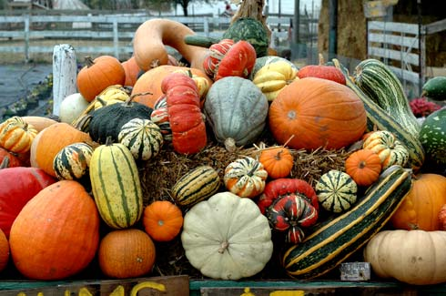
Dear Parents and Carers

Despite COVID, we have had a very good half term with children happy to be in class and meeting all their friends again. The children have easily adapted to new routines in school and thank you too for co-operating with our new procedures. Please see the school website for latest photos of recent activities including Early Years harvest celebrations.

Parents Evening – Alternative Arrangements
Unfortunately, due to restrictions we will not be hosting parents evening this term. Instead, teachers will write a short interim report for your child which will be sent to parents/carers via email from admin. The reports will be sent out over a course of three days - Wednesday 18th, Thursday 19th and Friday 20th November.

The main purpose of the report is to state how the pupils have returned to school, settled in and are managing with the core subjects and foundation areas.

If you would like to discuss a particular issue or concern please email admin on receipt of your report and the class teacher will be in touch to agree a time for a telephone call. All children with special educational needs will receive a telephone call.

COVID - UPDATE
It is very important that we continue to monitor COVID during the times school is closed, particularly during holidays.

Please text school on 07786207779 if your child or anyone in the household is suspected of having or has had a positive test for COVID-19.

Symptoms of Covid-19
- A fever – this means hot to the touch on the chest or back
- A continuous cough - a dry cough and coughing a lot for over an hour with
more than 3 episodes per day
- Loss or change of sense of taste or smell

It is important that the whole household self isolates and anyone in the household with symptoms gets tested as soon as possible. Contact www.nhs.uk/coronavirus. Only people with symptoms should get tested.

As soon as we are informed of the positive test result, we will carry out a risk assessment with Public Health to identify any other children or staff who may have been a close contact with the confirmed case prior to school closing. School will contact any family whose children need to isolate.

Fortunately, cases have been very low this half term. No children have had a positive test result for COVID. Two staff members have had COVID but both recovered quickly and returned to work.

Enjoy the half-term
Mrs Furno
Head Teacher

