

**Maths Ideas**

* How many objects got stuck in the tree? Can you count them through the story?
* How many now if we add:  
  - 1 more?  
  - 2 more?
* Investigate height! How tall was the tree? Do you think a ladder would reach? What could be long enough to reach the tall tree?

**Phonics / Reading Ideas**

* Can you sound out the items in the tree?
* Focus on words with ‘ee’ and ‘ck’ How many can you find in the story?
* Can you write these words with their sound buttons?
* Can you think of any other book Oliver Jeffers is the author of?

**Other Ideas**

* Talk about who you would call in an emergency.
* Where is your local:  
  - Police Station  
  - Fire Station  
  - Hospital / Doctors

Can you walk to these? Or find them on google maps?

* All the things in the tree managed to balance there! Investigate balancing different objects on top of each other. What is the tallest tower you can make?

**Writing Ideas**

* Write down the people you may go to for help.
* Who would you ask to help you get things out of the tree?
* Write down the feelings the boy may feel during the story. Fear, Hope, Perseverance?
* Write about a time you didn’t give up at something and succeeded!

Week 7 - People Who Help Us   
**STUCK**

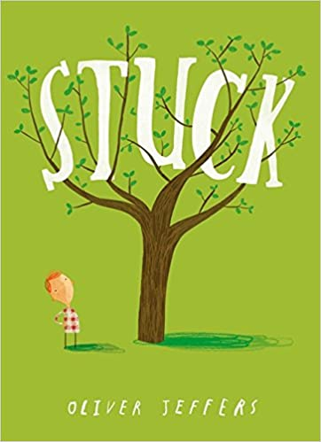

You can watch a reading of the book online:

YouTube: Stuck by Oliver Jeffers