 | Year 2 - Week 3
 | Learning | Activities
English | Elves and the Shoe Makers  What is a riddle?  Can you guess the riddle?  can you write your own riddle?  Class Book -The Lighthouse Keepers’ Lunch by Ronda and David Armitage's  Can you escribe the story setting? | https://www.talk4writing.com/wp-content/uploads/2020/04/Y2-Emma-Elves.pdf  Talk about the events in the story and re-read it if you need to.  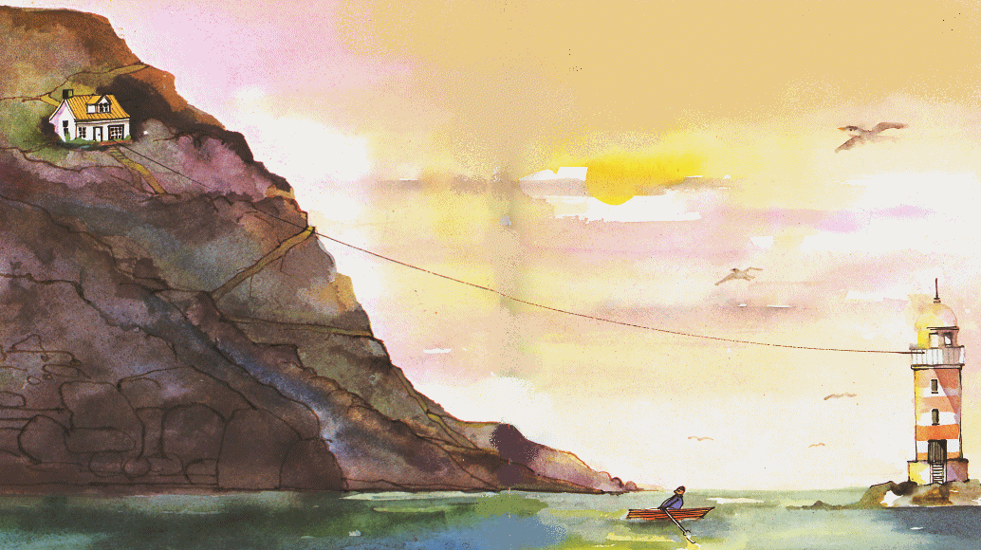  Read the riddle and guess what it is about. Page 17  Plan and write your own sea creature riddle.  Write a description of the setting using adjectives.  Mr Grinling lived in a small, white cottage perched high on a rocky cliff.  https://www.youtube.com/watch?v=46wCRq50Wwg
Mathematics | What number facts do you know?  How are addition and subtraction linked?  How can I add a 1 digit to a 2-digit number? | https://www.bbc.co.uk/bitesize/articles/zr2hnrd  Practice number bonds and explore how addition and subtraction are linked.  https://www.bbc.co.uk/bitesize/articles/z6vm6v4  Practice counting on and back in 1s.
Science | What creatures live in the sea, rock pools and coral reefs? | https://www.bbc.co.uk/programmes/p011l4gy - video, animals found in the ocean  https://www.bbc.co.uk/teach/class-clips-video/science-ks1-ks2-wonders-of-nature-underwater-world/zh3ygwx - video, animals found in the ocean  https://www.bbc.co.uk/bitesize/clips/zpfnvcw - video, rock pools  https://www.bbc.co.uk/bitesize/clips/znn6n39 – video, animals found in coral reefs  https://www.bing.com/images/search?q=creatures+that+live+in+the+sea&qpvt=creatures+that+live+in+the+sea&FORM=IGRE – pictures of different sea creatures  Draw pictures and label, make a sea creatures collage or write a fact file.
RE | What places are special to Christians and Muslims?  What places are special to you? | https://www.bbc.co.uk/bitesize/guides/znpbqp3/video Christian Church  https://www.bbc.co.uk/bitesize/clips/z74wmp3 Mosque
Geography | What is an ocean? Can you name the 5 oceans? | https://www.bbc.co.uk/bitesize/topics/z849q6f/articles/zmqwscw - oceans video  https://www.bbc.co.uk/bitesize/topics/zx882hv/articles/zsfkd2p - ocean video  https://www.kids-world-travel-guide.com/ocean-facts-for-kids.html - information about 5 oceans
Art/DT | What shapes, colours and patterns can you see on seaside objects? E.g. shells, pebbles | Observational drawings of seaside objects e.g. shells. Use the link with seaside pictures below if you don’t have any objects.  https://www.alamy.com/stock-photo/sea-shell.html
PSHE | What is the RNLI?  How can we stay safe at the seaside? | https://www.bbc.co.uk/bitesize/clips/z94jxnb - video with Barnaby Bear  https://rnli.org/youth-education/education-resources/videos  Make a leaflet or poster about the RNLI
PE | CBeebies, Andy’s Wild Workouts, Under the sea | https://www.youtube.com/watch?v=TCrFUD98U_Q&list=PLoOc9M0VgduMnQiJ56Gw5TX7wsGIF7kmv&index=1

