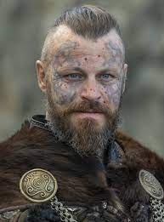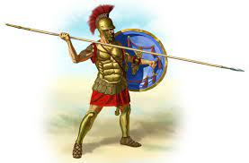

**Science**

In science we will be learning about forces and magnets in term 1 and light in term 2.

**Computing**

We will be coding this term. Code.org is a useful website your children will be using to learn the skill of coding and debugging.

**History**

This term we will be looking at invaders. First we will explore the romans, then the Anglo Saxons and Vikings. We will be looking at how they invaded, their similarities and differences and what it meant to the world.

**PSHE**

Families, relationships, choices and forgiveness.

**Spanish**

We will be learning to talk about ourselves and the things we do.

**PE**

**This term we will be doing Gymnastics.**

**Music**

We will be learning to play the glockenspiel.

**English**

**This term we will be reading;**

* The Twits – Roald Dahl
* Danny, the champion of the world – Roald Dahl
* Beowulf (legend & myth)
* The British – Benjamin Zephaniah
* Diary of a Wimpy Kid – Jeff Kinney

We will be working on our reading skills and exploring explanation texts and poetry too.

**Maths**

We are learning our times tables. From x1 to x12. We are aiming to answer within 6 seconds. We are exploring length, fractions and number this term.

**Geography**

We will be exploring atlases and computerized maps exploring Italy and its physical and human features.

**Art & Design / DT**

We will be using mosaics & creating a Viking ship.

Invasion, Diversity & Love