10th July, 2020

Dear Parents, Carers and Governors,
It has been a very strange summer term and we are looking forward to reopening to the full school in September. It will be great to welcome all the children back at the start of the new academic year on Wednesday 9th September.

Nursery 9.00 – 3.00

Reception 8.55 – 3.00

YRS 1 – 6 8.55 – 3.15

We will bring nursery children in after all other classes have entered the building.

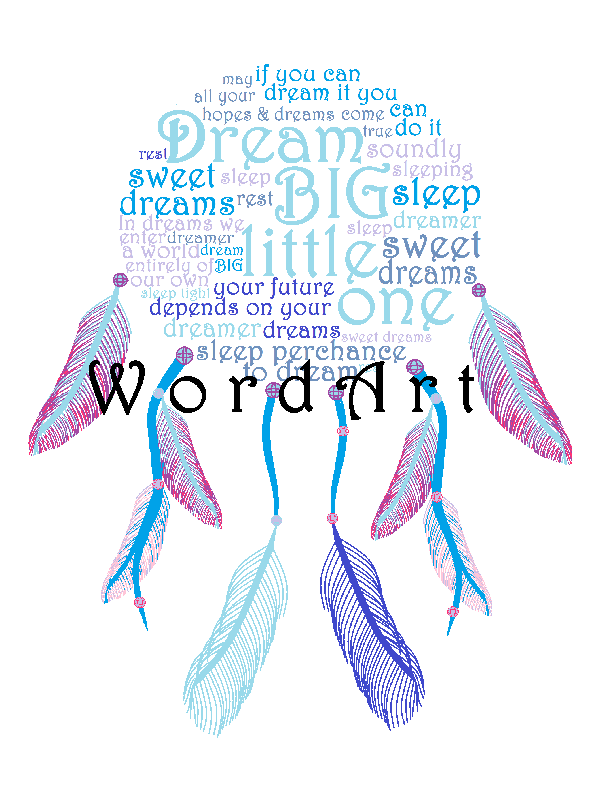
We understand that many of you may feel anxious about sending your children back to school. Be reassured that we have put in place many new procedures and social distancing measures to ensure minimal risk of infection. We have also been open to some children since March and procedures are well established. Please see following page for procedures etc.

I hope that next week children will have the opportunity to meet their new teacher on zoom. Information will be sent on Monday by email. There will also be plenty of time given in September to reintegrate children back into school and talk about their experiences and worries. We will be focusing on children’s mental health and well-being including creating a whole school display of dream catches, about their hopes for the future.

New Year Groups and Staffing

Year Group | Teacher | Support Staff
Nursery | Mrs McKay, Mrs Pattison | Mrs Vardy
Reception | Mrs Patterson, Mrs Wilkinson | Mrs Sadeghi
1 | Mrs Allison, Miss Cliff | Mrs Arnott, Mrs Tait (PM)
2 | Mrs Mann, Mrs Power | Mrs Tait (AM), Mr Pousson
3 | Miss Crick | Miss Lyons
4 | Miss Wallace | Mr Marshall
5 | Miss Lutton | Mr Aslam
6 | Mr Hetherington | Miss Furno

GOOD NEWS
Congratulations to Mr Hetherington who will be going on two weeks paternity leave in September; Miss Furno will cover in YR6.

CLUBS
Unfortunately, there will be some delay in resuming usual practices. There will be NO AFTERSCHOOL clubs initially in the autumn term but we hope to reintroduce them at some point after the October half term.

However, the five o’clock club will run Monday – Thursday £5 per session starting Monday 14th September. Payment will be required on Monday. This club will be for a small number of children of working parents only.

You will all be receiving your child’s school report this week. Please contact school in September if you need to discuss it with their previous class teacher.

If you have any concerns or questions, please contact school. Thank you for your understanding and we look forward to welcoming your child back into school – we’ve missed them!

Enjoy the summer holidays.
S Furno
Head Teacher

Health and Safety Procedures
We understand that many of you may feel anxious about sending your children back to school. Be reassured that we have put in place many new procedures and social distancing measures to ensure minimal risk of infection.
This includes:
- frequent and rigorous cleaning throughout the school building and regular washing of frequently touched surfaces;
- regular and thorough handwashing including use of sanitiser;
- Catch it, bin it, kill it routines;
- a one-way system throughout the school building together with social distancing markers;
- children seated at desks facing forward with their own pot of pens and pencils;
- staggered breaks and lunch times.

Children and staff will stay with their class throughout the week to minimise social contact with others. We will have three main groups – Early Years, Key Stage 1 and Key Stage 2.

We are also requesting your support and cooperation.

- Please provide your child with a water bottle.

- No personal belongings in school except PE kit. We will be sending reading books home but not library books. Reading books will be left for 72 hours before being reused.

- Please do not arrive early as there will be no playing in the yard before the bell.

- Wait outside the school yard (remember to stand at social distance from others): when the gate is opened, your child will be directed to wait on a marker in the yard.

- At the end of the day you will be directed to wait by a marker in the playground and your child will be sent to you.

- If you need to speak to a teacher, please phone school and the teacher will ring you when available.

- If you need to visit the school office in the morning, wait until the children have left the playground.

Thank you very much for your cooperation.

