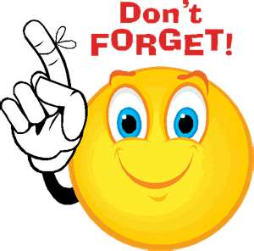
Our Week
(Things to remember)

Children should bring their reading folders
to school every day.

New spellings are usually given out on a Monday.
Spelling tests are on a Friday.

Library day is a Thursday.

Homework is given on a Friday each week and is to
be returned by the following Wednesday.

Whole school Achievers Assembly is on a Friday
9.10am – 9.30am – all parents are welcome!
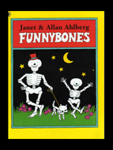

Spectacled Bears Class 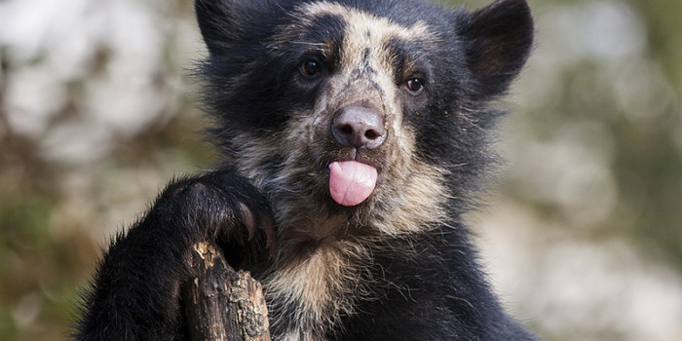
(Year 2)
Information Leaflet

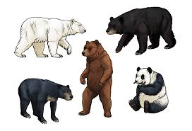
Our Theme: Bears, Bones and Toys

This term we will be:
- Reading Stories and describing characters and
settings, focusing on Funnybones.
- Using Contents and Index pages in information
books to find out about the world and countries
we have travelled from.
- Learning about healthy foods and the needs of
our bodies.
- Learning about famous people from the past,
such as Florence Nightingale.
- Learning to add and takeaway 2 digit number lines,
- Using place value counters.

Our Theme:
Our Theme: Bears, Bones and Toys

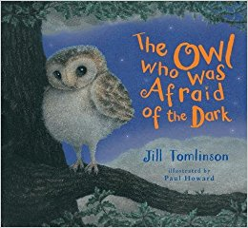

Next half term we will be:

- Writing our own version of stories, such as,
The Owl Who Was Afraid of the Dark
- Learning how to divide and multiply 2 digit
numbers.
- Learning how to find fractions such as ½ and ¼.
- Learning about Christmas and the Nativity.
- Designing and making Christmas Cards.
- Learning about toys from the past.
- Reading and writing our own stories.
- Reading and writing instructions.
- Rehearsing and performing our Christmas Nativity.
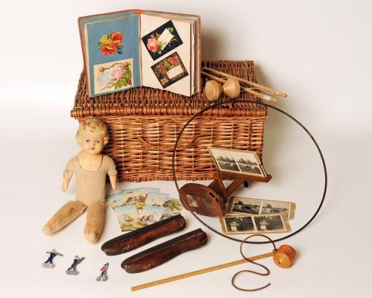


Some useful websites are:

www.bbc.co.uk/schools/scienceclips
www.phonicsplay.com
www.iboard.co.uk
www.ictgames.co.uk

Please feel free to see any member of
Y2 staff if you have any queries.

Mrs Power
Mrs Mann
Miss Robertson
Mr Pousson

Pupil progress meetings with parents
will take place during the second half
term.

