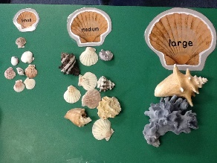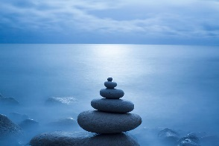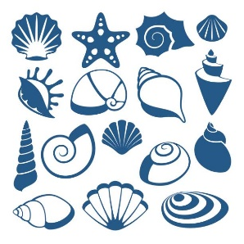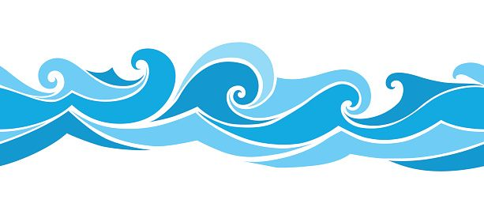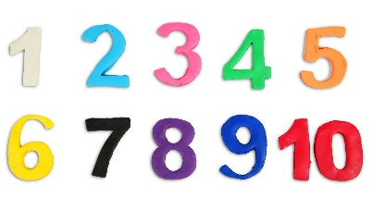

**Maths Ideas**

* If you are lucky enough to have shells in your house count them, or collect little pebbles and stones and count as many as you can.
* Use your shells or pebbles to make your own addition problems. E.g if you have 7 and the sea gives you some more how many will you have altogether?
* Investigate size with your shells and pebbles. Can you place them in size order from smallest to largest? Can you find something smaller than your smallest shell?

**Week 3 “Wave”**

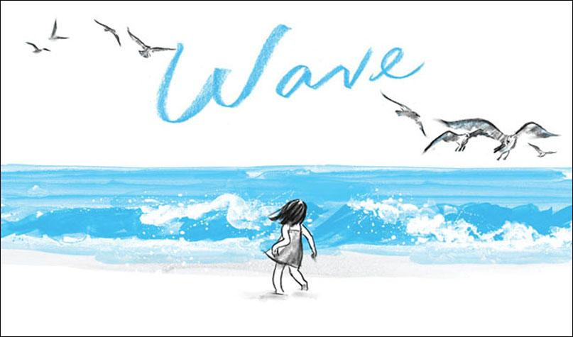

You can find a copy of this book on youtube

Please follow the link below

<https://www.youtube.com/watch?v=zTTIu78vtt0>

**Phonics/Reading Ideas**

* After listening to the story talk about what happened.
* Talk about the lack of words in this book, where are they? Why has the author decided to leave them out?
* What sounds would you expect to hear at the beach?
* Add your own narration to accompany the story.

**Writing Ideas**

* Write a story to go with the picture book.
* Send a letter to a friend or family member (from the girl’s perspective) and tell them about your day at the beach.
* Map the progression of the girls feelings throughout the story, how is she feeling as her day goes on? Write them as a story map and add labels for her emotions.

**Other Ideas**

* Visit the coast, the North East has some of the best beaches in the country!
* Make a water safety poster. How do you keep safe when playing in the sea?
* Explore the colour blue. Can you use paints, pencils or crayons to make different shades? How many different shades of blue can you find in your home or out on an adventure?
* Try and balance pebbles on top of each other. How tall can you build before they fall over?