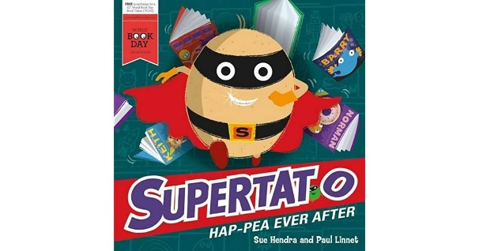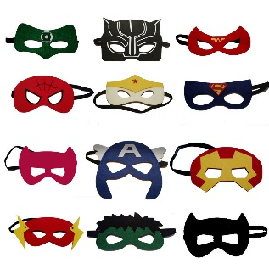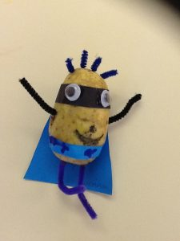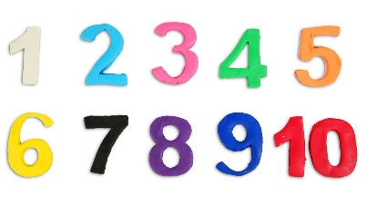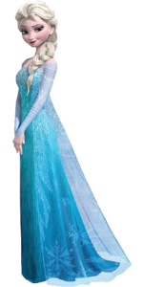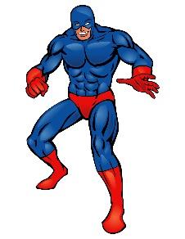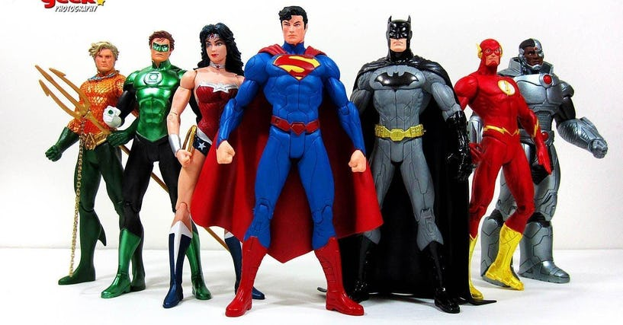

**Week 1 ‘Supertato’**

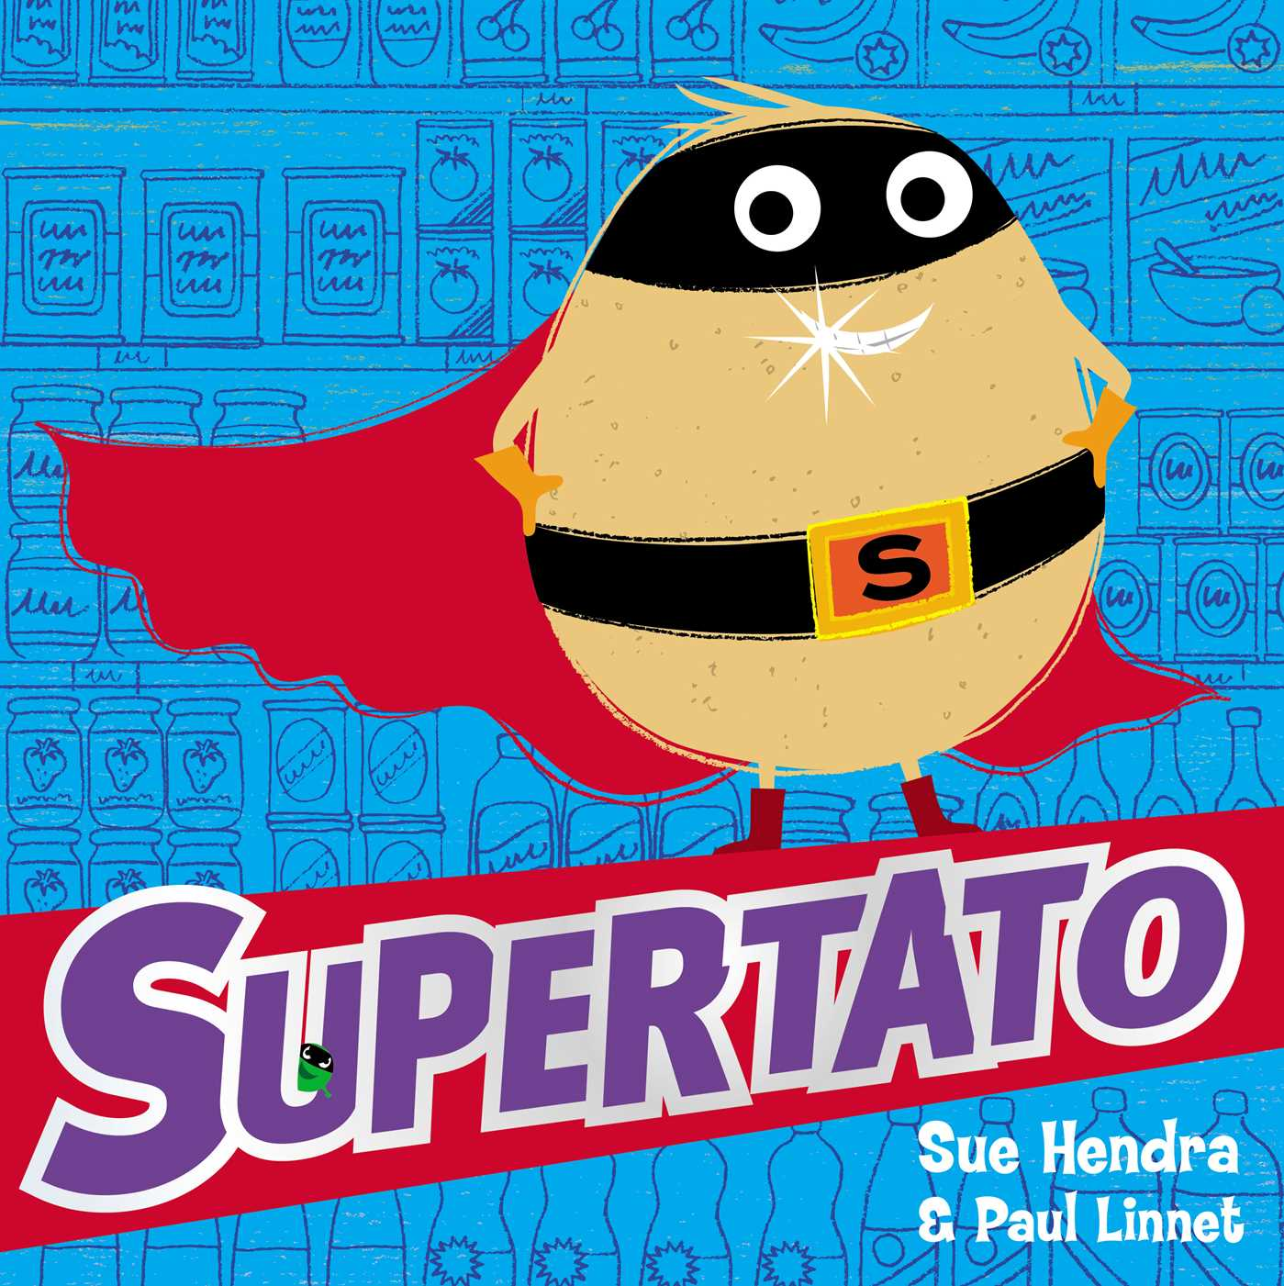

You can find a reading of this book on

YouTube – Books Alive Supertato

**Phonics/Reading Ideas**

* After listening to the story talk about what happened.
* Who are the characters in the story?
* Who is the author of the book? Research which other stories have been written by this author.
* Listen to some more Supertato stories on YouTube on Books Alive e.g Supertato Hapea Ever After.
* Do you know any other stories about Superheroes?

**Writing Ideas**

* Make a WANTED poster for the pea villain from the story ‘Supertato’.
* Draw a picture of Supertato then label him e.g mask, cape.
* Think about what you are good at? Write down your ‘superpwers.’
* Draw and write about one of your favourite toys/characters that could team up with Supertato. It could be anyone from Elsa to Captain America.

**Other Ideas**

* Design and create your own potato superhero.
* Youtube – Cosmic Kids Yoga – Spider Power
* Design a healthy superhero smoothie to give your superhero lots of energy. You could write down the ingredients and instructions on how to make it.
* Design a superhero mask and have a Superhero picnic outside wearing your mask.

**Maths Ideas**

* If you have superhero figures at home can you put them in size order? If not you could pretend anything are superheroes e.g carrots, pencils, straws and put them in size order from shortest to tallest.
* Count how many superhero figures/pretend superheroes you have.
* Can you split them into two groups – how many are their in total?
* -order numbers from 0-5, 0-10 or 0-20.