[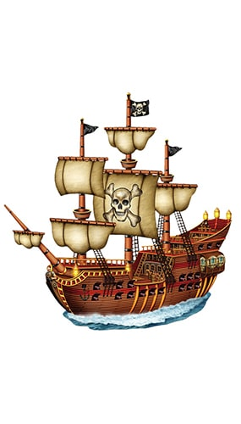](https://www.google.com/url?sa=i&url=https%3A%2F%2Fwww.partyrama.co.uk%2Fpirate-ship-jointed-cutout%2F&psig=AOvVaw19JKE4OCd3m5BaCZyd7e5E&ust=1593678880507000&source=images&cd=vfe&ved=0CAIQjRxqFwoTCIiMts7Sq-oCFQAAAAAdAAAAABAI)[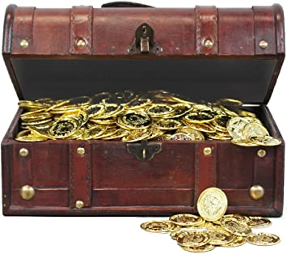](https://www.google.com/url?sa=i&url=https%3A%2F%2Fwww.amazon.co.uk%2FPirate-Treasure-Chest-144-Coins%2Fdp%2FB0054LI43U&psig=AOvVaw2Yaz655_0e8GWO2PksQLlt&ust=1593678670635000&source=images&cd=vfe&ved=0CAIQjRxqFwoTCMD1o-rRq-oCFQAAAAAdAAAAABAQ)[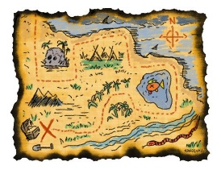](https://www.google.com/url?sa=i&url=https%3A%2F%2Fwww.pinterest.com%2Fpin%2F303641199851645945%2F&psig=AOvVaw399GiIXCy8HV4JYMvP4CSB&ust=1593678620205000&source=images&cd=vfe&ved=0CAIQjRxqFwoTCKD1t9LRq-oCFQAAAAAdAAAAABAI)[](https://www.google.com/url?sa=i&url=https%3A%2F%2Fseamarknunn.com%2Facatalog%2FMeridian-Zero-Novelty-Flag---Jolly-Roger-CU42330_2.html&psig=AOvVaw2QC4yGvzoZMW5fyqLUBjgS&ust=1593678493885000&source=images&cd=vfe&ved=0CAIQjRxqFwoTCKihmpbRq-oCFQAAAAAdAAAAABAF)[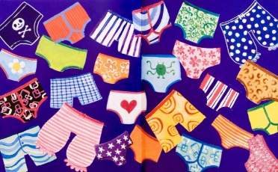](https://www.google.com/url?sa=i&url=https%3A%2F%2Fwww.blipfoto.com%2Fentry%2F233736&psig=AOvVaw03LnhDaGIq-tZgEa3E9HpO&ust=1593678734674000&source=images&cd=vfe&ved=0CAIQjRxqFwoTCOi98IjSq-oCFQAAAAAdAAAAABAK) 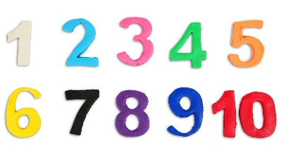

**Writing Ideas**

* Can you explain why pirates love underpants so much?
* Draw yourself as a pirate, what would be your pirate name? What do you love?
* All pirates have a set of rules they follow, it’s called the Pirate’s Code. Make up your own code, what rules would you have if you were a pirate?
* Pretend you have landed on Big Knickers Bay, send a message in a bottle to someone.

**Phonics/Reading Ideas**

* What problems did the pirates encounter throughout the book? How did they solve or overcome them?
* If you were a pirate what sounds would you expect to hear aboard ship?
* Can you talk like a pirate for the day?
* There are lots of rhyming words in this book, how many can you find? Can you think of any more?
* Play “buried treasure” on <https://www.phonicsplay.co.uk/resources>

**Maths Ideas**

* Go hunting for “treasure” in your house. Can you find any coins to count? How much is each coin worth? Can you use your coins to make your own addition problems?
* Uh oh, pirates have been stealing from your treasure chest! You used to have 10 pennies but now there are only 3, how many have those pesky pirates taken?

**Week 4 “Pirates Love Underpants”**

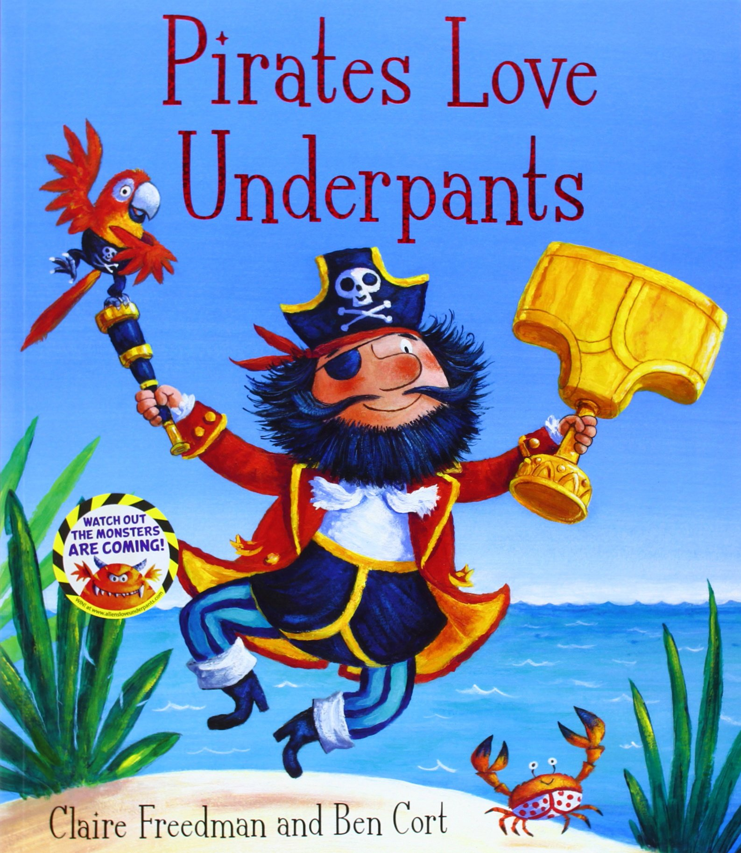

You can find a copy of this book on youtube

Please follow the link below

[www.youtube.com/watch?v=Vd8_Y1bEzA8](http://www.youtube.com/watch?v=Vd8_Y1bEzA8)

**Other Ideas**

* Hide your favourite underpants and make a treasure map to show where you’ve hidden them.
* Pirates love to sing while they’re at sea. Research “Sea Shanty Songs”, have a listen to some and try to make up one of your own.
* Can you learn a pirate jig? Have a look at Mickey Mouse and his friends for some inspiration.

[www.youtube.com/watch?v=G06GXPMaDUM](http://www.youtube.com/watch?v=G06GXPMaDUM)

* Make your own pirate flag and hang it somewhere for everyone to see.