Extra Information:

Monday: Spellings given to learn.
Book bag return with evidence of reading noted in reading records.
PE

Tuesday: PE

Friday: Return of homework and learning logs.
Arithmetic test. Achievement assembly.
Spelling test.
PE kit taken home.
Homework task given.

This term our project is Broomsticks,
Fireworks and Stars.
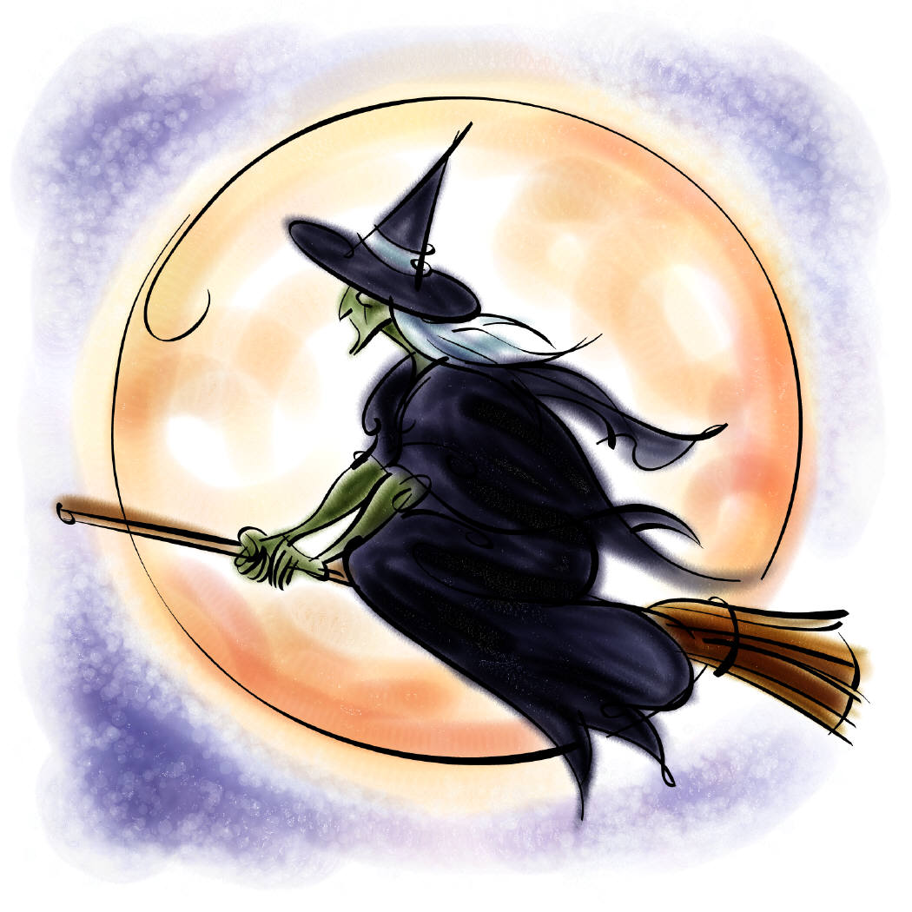


This half term we will be:

- Studying the Shang Dynasty and finding out how we know so much about something that happened such a long time ago.
- Reading ‘Hetty Feather’ and answering questions about the story.
- Studying Harry Potter and the Philosopher’s Stone
- Writing explanations about how broomstick’s work.
- Exploring different materials and their properties.
- Finding which materials are most absorbent to clean up spilt spells!
- Measuring the temperature of different potions.
- Making witches hats/cloaks and spiders as part of our display.
- Researching on the internet facts about witches.

Next half term we will be:

- Researching fireworks and Guy Fawkes on the internet.
- Writing poems about fireworks.
- Using drama to re-enact the Gunpowder Plot.
- Writing reports about fireworks and Guy Fawkes.
- Using pastel and paints to create firework pictures.
- Exploring using a bulb in a circuit to make a firework light up.

You can help by visiting the library to look at books for children about witches, fireworks and Guy Fawkes. Children could bring in any artefacts or books that are linked to the topic.

Some useful websites are:

- http://www.woodlands-junior.kent.sch.uk/customs/Guy.html.

- http://www.bbc.co.uk/dna/h2g2/A199488.

- Top 10 Shang Dynasty Facts for Kids - Twinkl Homework Help

- http://primaryhomeworkhelp.co.uk/revision/Science/electricity.htm

- http://www.bbc.co.uk/schools/scienceclips/ages/6_7/electricity.shtml.

- http://www.bbc.co.uk/schools/scienceclips/ages/7_8/characteristics_materials.shtml.



