 | Year 2 - Week 2
 | Learning | Activities
English | Elves and the Shoe Makers Can you retell the events in the story?  Plan your own story about elves who help people. What will your elves be called? Where will the story take place?  Class Book -The Lighthouse Keepers’ Lunch by Ronda and David Armitage's  Can you retell the story? | https://www.talk4writing.com/wp-content/uploads/2020/04/Y2-Emma-Elves.pdf  The Elves and the Shoe Maker – Re-read and discuss the story together. Retell the story.  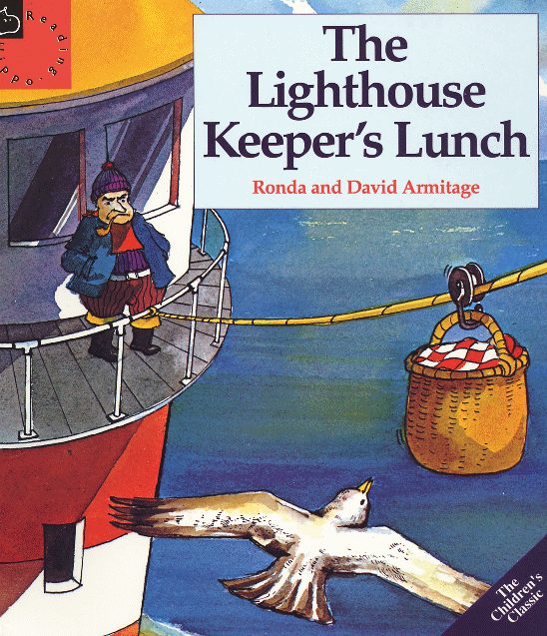  Plan your story using the story mountain to help, page 14  Write your own story using capital letters and full stops.  Draw a story map of the main events in ‘The Lighthouse Keeper’s Lunch’. https://www.youtube.com/watch?v=46wCRq50Wwg  Retell the story to your family.
Mathematics | Shape and Pattern  Can you describe and make patterns using shapes, objects and numbers? | https://www.bbc.co.uk/bitesize/articles/z338bqt  Complete different repeated patterns.  What different patterns can you make with objects around your house e.g. Lego, paint, draw patterns
Science | What do plants need to grow? | https://www.bbc.co.uk/bitesize/topics/zpxnyrd/articles/zxxsyrd - video and quiz  Draw a labelled picture and write an explanation.
RE | What special places are there around the world?  What places do you enjoy going to? What places do you think are beautiful in the world? | https://www.bbc.co.uk/bitesize/clips/z62hyrd The world that God made.  Draw or write about places in the world that you think are beautiful.
Geography | What are the human (pier, lighthouse, houses) and physical (rocks, hills, bog, cliffs) features of islands? | Look at the map and identify the physical (natural) features and human features (those made by humans). Draw and label them.  https://www.bbc.co.uk/iplayer/episode/b055fqsm/katie-morag-series-2-12-katie-morag-and-the-big-balloon Katie Morag watch the video and identify physical and human features.  https://www.bing.com/images/search?q=map+of+island+of+struay+Katie+Morag&FORM=HDRSC3 – map of island
Art/DT | What is your favourite sandwich?  What fillings do you like?  Can you make a sandwich? | Linked to our class text ‘The Lighthouse Keeper’s Lunch’  Design, draw or make your favourite sandwich. What ingredients do you need?
PSHE | What different emotions do we have?  How can I manage my emotions? | https://www.bbc.co.uk/bitesize/articles/zmmgrj6  Managing emotions
PE | CBeebies, Andy’s Wild Workouts, Beach | https://www.youtube.com/watch?v=DqAOMrZkht0&list=PLoOc9M0VgduMnQiJ56Gw5TX7wsGIF7kmv&index=4
Computing | What is computer coding? | https://www.bbc.co.uk/bitesize/articles/zkjy382 video and activities

