At home children must:
- Read every day – this can be on Bug Club or books
- Create stories, instructions, recipes and fact files wherever possible
- Learn their times tables inside out. Including missing number e.g. 8 X __ = 48
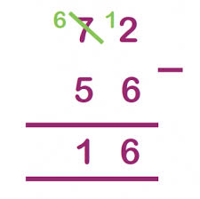
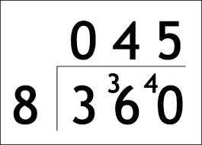
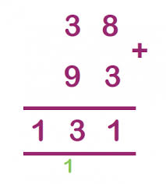
- Practice the formal method of addition, subtraction, multiplication and division. e.g.

- Become more fluent with fractions – finding fractions of amounts and linking with percentages.
- Practice observational sketching skills – drawing what you see, not what you think you see.
Useful websites:
All subjects - https://www.bbc.co.uk/bitesize/levels/zbr9wmn
Maths - https://www.mathplayground.com/
Times tables - https://play.ttrockstars.com/auth/school/student
Reading - https://www.activelearnprimary.co.uk/login?c=0
Coding - code.org/join
Bug Club Login Code login
Username: Class code:
Password: year5
School Code: CCPS
Movies linked to our topics:
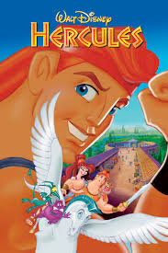
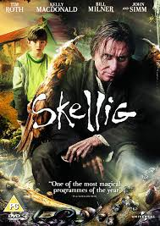

(Please check that these are age appropriate for your children before watching)
Next term out topic is:
Mythical Beasts and Impossible Missions
English
Greek Myths:
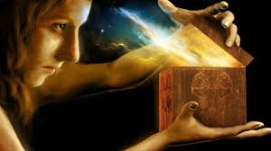
- King Midas and the Golden Touch
- Pandora’s Box
- Icarus
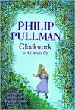
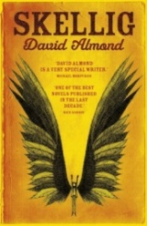
Figure out the lesson from each myth and then write your own version.
Fantasy:
- Skellig by David Almond
- Clockwork by Phillip Pullman
Research what the genre “fantasy” means. Write our own fantasy stories.
Science
Forces: Gravity, air resistance, water resistance, friction, mechanism, gear, pulley.
Earth and Space: Planet, solar system, celestial body, rotate, orbit, axis.
Use websites (such as BBC Teach and Bitesize) to research these KS2 Science topics. Can you create your own experiments?
History and Geography
Find out about Ancient Greece and understanding its impact upon the modern world.
Research what Greece is like today and compare Athens to Newcastle.

