 | Year 2 - Week 6
 | Learning | Activities
English | Sharks  Can you write a report about sharks?  Can you use sub-headings? e.g. What are sharks? What do sharks look like? What do sharks eat? | 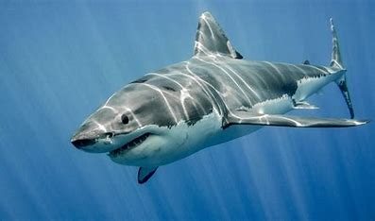  https://www.youtube.com/watch?v=tfWMwG6aYzQ video about sharks  https://www.sciencekids.co.nz/sciencefacts/animals/shark.html  https://kidzone.ws/sharks/facts1.htm information about sharks  Write a report or fact file about sharks.
Mathematics | Can you find fractions of shapes and numbers? | https://www.bbc.co.uk/bitesize/articles/z4j83j6  https://www.bbc.co.uk/bitesize/articles/z6cbhcw  Videos and activities find fractions of shapes and numbers.
Science | What is a food chain? | https://www.bbc.co.uk/bitesize/clips/z96r82p video  https://www.bbc.co.uk/bitesize/clips/z8hxpv4 video  https://www.bbc.co.uk/teach/class-clips-video/science-ks1-the-food-chain/zbr8d6f video
History | What is different and what is the same about seaside holidays now and in the past? | https://www.peacehavenheights.co.uk/attachments/download.asp?file=2289&type=pdf Make a table now and then and compare seaside holidays.  Write a report or draw and label pictures of a seaside holiday now and from the past.
Art/DT | How will you make your lighthouse? What will you need? How will you join and decorate it? | Make your lighthouse using your plan from last week.  Join the materials together and decorate it.  Or make a lighthouse out of Lego or anything you have!
PSHE | Sally and the Limpet Shell.  What does this story tell you about how to look after animals at the seaside? | https://www.youtube.com/watch?v=HX8vgBF1_G8  Should Sally of taken the limpet shell off the rock?  Why not?  How can we take care of creatures?
PE | Can you follow the instructions?  Can you achieve the challenges? | https://www.youtube.com/user/WestYorkshireSport/videos  #THISISPE - Short PE lessons every Monday, Wednesday and Friday. Challenges to do at home without specialist equipment.
Computing | Can you organise and present your information about lighthouses?  Can you include some images? | Present their information about sharks from English in any way you like e.g. PowerPoint, poster, fact file. Include images of sharks.

